

COLLEGE TIME TRACKER (CTT)
Project Supervisor
Mr. Sajjad Abdullah
Assistant Professor (Computer Science)
Government Graduate College Sadiq Abad
Submitted By
Name: Kainat Najamudin
University Roll No: 2023-SD
BSCS 2023-25
CERTIFICATE
This is to certify that Kainat Najamudin (2023-SD), BSCS 2023-25 has worked on and completed their Software Project at Department of Computer Science, Government Graduate College, Sadiq Abad in partial fulfillment of the requirement for the degree of Bachelor of Science in Computer Science (BSCs) under my guidance and supervision.
In our opinion, it is satisfactory, up to the mark, and therefore fulfills the requirements of Bachelor of Science in Computer Science (BSCS).
Supervisor / Internal Examiner
Mr. Sajjad Abdullah
Assistant Professor (Computer Science),
Government Graduate College Sadiq Abad
___________________
(Signature)
External Examiner/Subject Specialist
___________________
(Signature)
Accepted By:
_____________
(For office use)

DEDICATION
“This project is devoted to my elder brother, whose constant encouragement
and selfless support have been my greatest motivation. His belief in my abilities has always pushed me to move forward with
confidence. I owe much of my progress to his guidance, strength, and the silent
sacrifices he has made for my success.”

ACKNOWLEDGEMENT
I extend my heartfelt gratitude to my respected supervisor, Mr. Sajjad Abdullah, for his continuous guidance, encouragement, and valuable insights throughout the development of this project. His expertise and patience have been a constant source of motivation and learning. I sincerely appreciate his time, support, and constructive feedback, which played a vital role in the successful completion of my project, College Time Tracker.

Abstract
The College Time Tracker (CTT) is a web-based academic management system designed to eliminate the manual and error-prone process of creating and distributing class timetables in academic institutions. Traditional scheduling methods rely on spreadsheets and manual coordination between departments, which frequently result in overlapping classes, double-booked rooms, and teacher scheduling conflicts. CTT addresses this problem by providing a centralized, role-based platform where an Administrator, Academic In-Charge, Teacher, and Student each interact through dedicated dashboards suited to their responsibilities.
The system allows authorized staff to manage user accounts, academic programs, classes, subjects, sections, rooms, and periods, and to build a weekly timetable through an interactive grid builder. A core feature of the system is its automated conflict-detection engine, which cross-checks every new timetable entry against existing entries to prevent a teacher from being scheduled in two classes during an overlapping time period.
The system is built using PHP for server-side logic, MySQL/MariaDB for relational data storage, and HTML5, CSS3, Bootstrap 5, and JavaScript for a responsive front-end. Passwords are stored using secure one-way hashing, and access to each module is restricted using role-based access control. The final system was tested using black-box testing techniques covering positive, negative, and boundary test cases, achieving a high pass rate across all functional modules.
The outcome is a lightweight, reliable, and easy-to-use academic scheduling platform suitable for colleges and small universities, reducing administrative workload and eliminating scheduling conflicts.
Keywords: Timetable Management, Web Application, MySQL, Role-Based Access Control, Conflict Detection
Table of Contents
Chapter 1: 0
Introduction 0
1.1 Background of the Study 1
1.2 Problem Statement 1
1.3 Objectives 1
1.4 Scope of the Project 2
1.5 Significance of the Project 2
1.6 Overview of Proposed System 3
1.7 Tools and Technologies 3
Chapter 2: 4
Requirements 4
Specification 4
2.1 Overall Description 5
2.2 Functional Requirements 5
2.3 Non-Functional Requirements 6
2.3.1 Performance Requirements 6
2.3.2 Security Requirements 6
2.3.3 Usability Requirements 6
2.3.4 Reliability Requirements 6
2.3.5 Availability Requirements 6
2.3.6 Scalability Requirements 6
2.4 System Users 7
2.5 System Constraints 7
2.6 Use Case Diagram 8
2.7 Use Case Descriptions 8
Chapter 3: 11
Design and Analysis 11
3.1 System Architecture 12
3.2 Data Flow Diagram 13
3.3 Entity Relationship Diagram 16
3.4 UML Diagrams 19
3.5 Database Design 23
3.6 User Interface Design 30
Role Dashboard 32
Chapter 4: 34
Development 34
4.1 Development Environment 35
4.2 System Modules 35
4.2.1 Authentication Module 35
4.2.2 Admin Module 35
4.2.3 Timetable Module 35
4.2.4 Reporting Module 35
4.3 Key Implementation Details 36
4.3.1 Description of the Conflict Check Logic 36
4.3.2 Validation Logic 38
4.3.3 Business Rule 38
4.4 APIs / Third-Party Integrations 38
Chapter 5: 39
Software Testing 39
5.1 Testing Strategy 40
5.2 Test Plan 40
5.3 Test Cases 40
5.4 Black Box Testing 42
5.6 Bug Reports 42
Chapter 6: 43
Implementation 43
6.1 Hardware Requirements 44
6.2 Software Requirements 44
6.3 Installation Procedure 44
6.4 Deployment Details 46
6.5 User Manual 47
6.5.1 Introduction to the User Manual 47
6.5.2 System Access Requirements 48
Chapter 7: 81
Conclusion and 81
Future Enhancement 81
7.1 Conclusion 82
7.2 Limitations 82
7.3 Future Enhancements 82
Chapter 8: 83
References 83
8.1 APA Format 84

Chapter 1:

Introduction

1.1 Background of the Study
Domain Overview: Academic scheduling is one of the most repetitive yet critical administrative functions in any college. It involves assigning subjects, teachers, rooms, and time periods to multiple classes across different programs and semesters, while avoiding overlaps.
Current System: In most colleges, timetables are currently prepared manually using spreadsheet software such as Microsoft Excel. The Academic In-Charge collects teacher availability, room availability, and subject load individually and constructs the timetable manually before printing/distributing hard copies or PDF files.
Existing Problems:
- Manual timetables frequently contain human errors, resulting in double-booked teachers or rooms.
- There is no centralized system for teachers or students to view their personal schedule online.
- Updates to the timetable are not reflected in real time, causing confusion.
- Historical records of previous timetables are not properly maintained.
- There is no automated way to generate reports such as teacher workload.

1.2 Problem Statement
There is no centralized, automated system in the college that allows academic staff to create, manage, and distribute class timetables while automatically preventing scheduling conflicts, and that allows teachers and students to view their personal schedules through a secure, role-based online platform.

1.3 Objectives
General Objective:
To design and develop a web-based College Time Tracker system that automates the creation, management, and distribution of academic timetables while preventing scheduling conflicts.
Specific Objectives:
- Develop a secure, role-based login system for four types of users.
- Design a relational database to store users, academic entities, and timetable data.
- Implement a module to manage academic entities (Programs, Classes, Subjects, Sections, Rooms, Periods).
- Develop an interactive timetable builder with a grid-based interface.
- Implement an automated conflict-detection algorithm to prevent double-booking of teachers.
- Provide teachers and students with a personalized dashboard to view their schedule.
- Generate workload and scheduling reports for administrative use.
- Evaluate the system through structured black-box testing.

1.4 Scope of the Project
Included Features:
- User management for Administrator, Academic In-Charge, Teacher, and Student.
- Management of Programs, Classes, Subjects, Sections, Rooms, and Periods.
- Interactive timetable builder with automated conflict prevention.
- Role-based dashboards and access control.
- Teacher workload and class-load reports.
- CSV export and print-friendly timetable view.
Excluded Features:
- Mobile native application (Android/iOS).
- SMS/Email notification integration.
- Payment or fee management modules.
- Multi-campus/multi-branch synchronization.

1.5 Significance of the Project
Academic Value: The project provides hands-on experience in database design, authentication, role-based access control, and algorithm design (conflict detection), reinforcing concepts learned in Software Engineering and Database Systems courses.
Industry Value: Small and medium colleges that cannot afford commercial ERP systems can adopt a lightweight system such as CTT to digitize their scheduling process at low cost.
Beneficiaries: Administrators, Academic In-Charge staff, Teachers, and Students all directly benefit from reduced manual effort and improved schedule accuracy.

1.6 Overview of Proposed System
CTT is a centralized web application in which an Administrator creates Academic In-Charge accounts; the Academic In-Charge in turn manages Teacher and Student accounts and constructs the timetable using a grid builder that maps Classes (rows) against Periods (columns). Each cell may contain one or more entries (Subject, Teacher, Room, Section, Days). Before an entry is saved, the system automatically checks whether the selected teacher is already assigned to another class during an overlapping day/period combination; if a conflict is found, the entry is rejected with a clear error message. Teachers and Students log in to view only their own relevant schedule.

1.7 Tools and Technologies
Category | Technology
Programming Language | PHP 8.x, JavaScript (ES6)
Frontend | HTML5, CSS3, Bootstrap 5, Font Awesome
Database | MySQL / MariaDB
Server / Platform | Apache (XAMPP), Web Browser
IDE | Visual Studio Code
Diagramming | draw.io / Lucidchart

Chapter 2:

Requirements

Specification

2.1 Overall Description
Product Perspective: CTT is a standalone, self-contained web application that does not depend on any external institutional system. It operates on a standard LAMP/WAMP stack.
Product Functions: User management, academic entity management, timetable construction, conflict prevention, and reporting.
User Characteristics: Administrators possess technical/system-management knowledge; Academic In-Charge staff have moderate computer literacy; Teachers and Students require only basic computer literacy to view schedules.

2.2 Functional Requirements
FR ID | Requirement | Actor
FR-01 | The system shall allow the Administrator to log in and log out securely. | Administrator
FR-02 | The system shall allow the Administrator to manage (create, update, delete) Academic In-Charge accounts. | Administrator
FR-03 | The system shall allow the Administrator to manage the master timetable. | Administrator
FR-04 | The system shall allow the Administrator to assign instructors to classes/courses. | Administrator
FR-05 | The system shall allow the Administrator to generate and view system reports. | Administrator
FR-06 | The system shall allow the Administrator to back up and restore the database. | Administrator
FR-07 | The system shall allow the Academic In-Charge to log in and log out securely. | Academic In-Charge
FR-08 | The system shall allow the Academic In-Charge to manage Teacher and Student accounts. | Academic In-Charge
FR-09 | The system shall allow the Academic In-Charge to manage the timetable. | Academic In-Charge
FR-10 | The system shall allow the Academic In-Charge to assign instructors to classes/courses. | Academic In-Charge
FR-11 | The system shall allow the Academic In-Charge to generate and view reports. | Academic In-Charge
FR-12 | The system shall allow the Teacher to log in and log out securely. | Teacher
FR-13 | The system shall allow the Teacher to view their personal timetable. | Teacher
FR-14 | The system shall allow the Student to log in and log out securely. | Student
FR-15 | The system shall allow the Student to view their personal timetable. | Student
FR-16 | The system shall automatically detect and prevent overlapping teacher assignments. | System
FR-17 | The system shall allow authorized users to export the timetable to CSV and print it. | Admin / In-Charge
Table 2.1: Functional Requirements

2.3 Non-Functional Requirements

2.3.1 Performance Requirements
- The system shall load the timetable grid within 3 seconds under normal load.
- The conflict-check algorithm shall complete within 1 second per entry.

2.3.2 Security Requirements
- Passwords shall be stored using one-way hashing (bcrypt).
- Sessions shall expire after a period of inactivity.
- Each module shall enforce role-based access control.

2.3.3 Usability Requirements
- The interface shall be responsive across desktop, tablet, and mobile screens.
- Error messages shall be clear and actionable.

2.3.4 Reliability Requirements
- The system shall correctly persist all CRUD operations to the database without data loss.

2.3.5 Availability Requirements
- The system shall be available during standard operating hours (8 AM – 6 PM) with minimal downtime.

2.3.6 Scalability Requirements
- The database schema shall support the addition of new programs, classes, and users without structural change.

2.4 System Users
Role | Description
Administrator | Full system control; manages Academic In-Charge accounts and system settings.
Academic In-Charge | Manages Teacher/Student accounts and constructs the timetable.
Teacher | Views personal weekly teaching schedule.
Student | Views personal class timetable.

2.5 System Constraints
- Requires a web server supporting PHP 8.x and MySQL/MariaDB.
- Requires a modern web browser with JavaScript enabled.
- Limited to single-institution deployment (no multi-tenant support).

2.6 Use Case Diagram

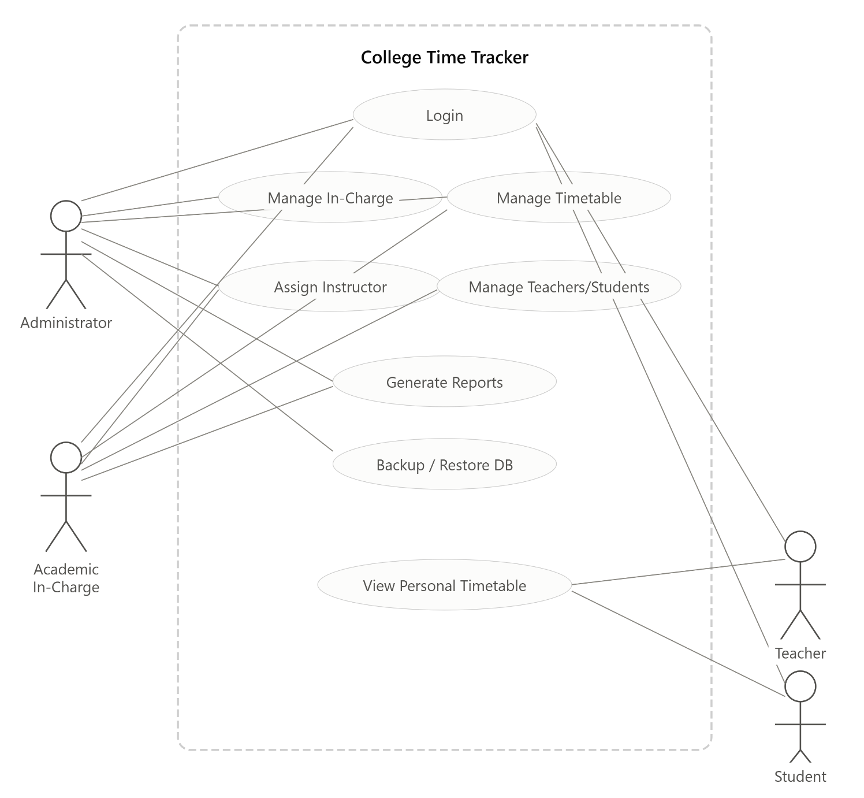
Figure 2.1, the system supports four actors, each with a distinct set of use cases.

2.7 Use Case Descriptions
Use Case: Login
Field | Detail
Use Case Name | Login
Actor | Administrator / Academic In-Charge / Teacher / Student
Preconditions | User must already have a registered account.
Main Flow | 1. User opens login page. 2. User enters username and password. 3. System validates credentials against the database. 4. System redirects the user to the role-specific dashboard.
Alternate Flow | If credentials are invalid, the system displays an error message and remains on the login page.
Postcondition | User session is created and the user is logged into their dashboard.
Use Case: Manage Timetable
Field | Detail
Use Case Name | Manage Timetable
Actor | Administrator / Academic In-Charge
Preconditions | User must be logged in with sufficient privileges.
Main Flow | 1. User selects Class and Period. 2. User selects Subject, Teacher, Room, Section, and Days. 3. System checks for scheduling conflicts. 4. If no conflict, the entry is saved and grid is refreshed.
Alternate Flow | If a conflict is detected (same teacher, overlapping day/period, different class), the system rejects the entry and displays a conflict message.
Postcondition | Timetable entry is added/updated in the database.
Use Case: View Personal Timetable
Field | Detail
Use Case Name | View Personal Timetable
Actor | Teacher / Student
Preconditions | User must be logged in.
Main Flow | 1. User navigates to "My Timetable". 2. System filters the master timetable to only the entries relevant to the logged-in user. 3. System displays the filtered grid.
Alternate Flow | If no entries exist, system displays "No classes assigned yet."
Postcondition | User views their personal schedule on screen.

Chapter 3:

Design and Analysis

3.1 System Architecture
3-Tier Architecture of CTT System

The College Timetable Tracker (CTT) is built on a classic 3-tier architecture, which separates the system into three distinct layers: Presentation, Application, and Data. Each tier has a specific role and communicates with the adjacent tier in a structured way.

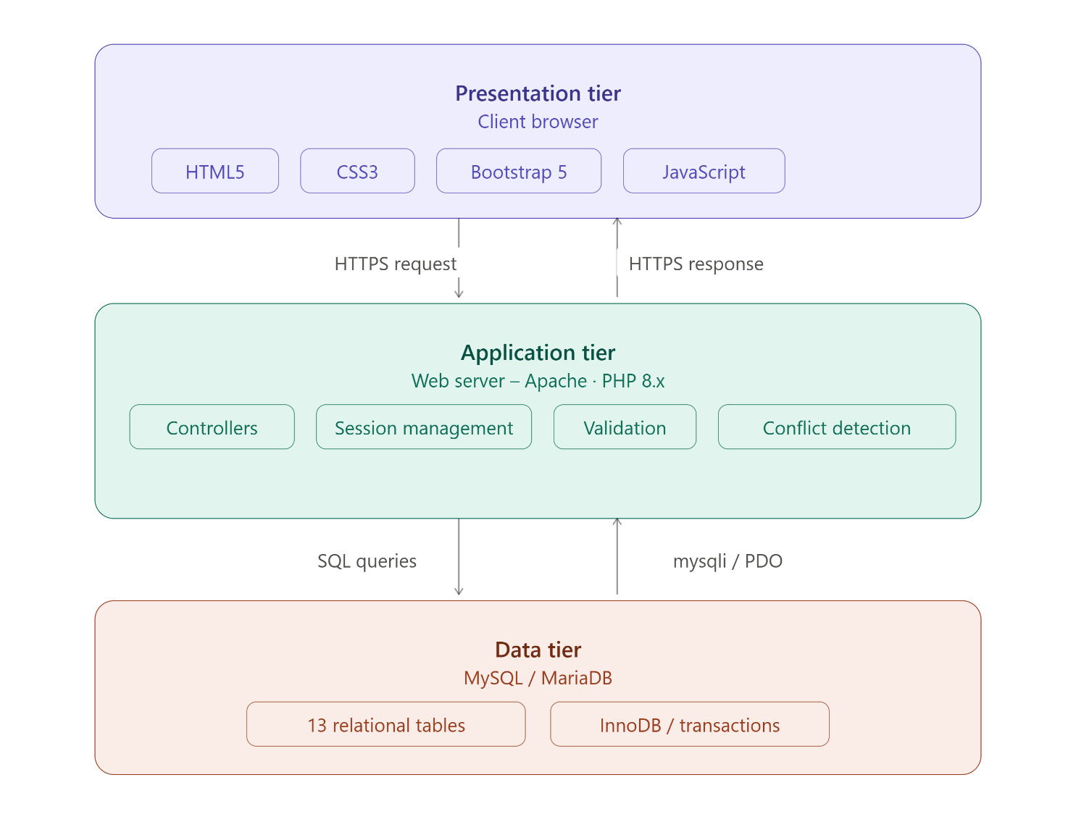
Figure 3.1: System Architecture (3-Tier)

Communication Flow

User browser → HTTPS request → Application tier

Application tier → SQL queries → Database

Database → mysqli/PDO → Application tier

Application tier → HTTPS response → User browser

This architecture ensures a clean separation of concerns, making the system more secure, maintainable, and scalable.

3.2 Data Flow Diagram
1. Level 0 DFD
The CTT system acts as the central process that receives inputs from and provides outputs to all users. There are four main actors involved:
- Administrator — The admin manages user accounts, timetables, and generates reports. The admin has the highest level of access in the system.
- Academic In-Charge — This role is responsible for managing teachers, students, and timetable assignments within their department.
- Teacher — The teacher interacts with the system to view their personal timetable, showing which classes they are assigned to teach.
- Student — The student uses the system to view their personal class timetable based on their enrolled program and section.

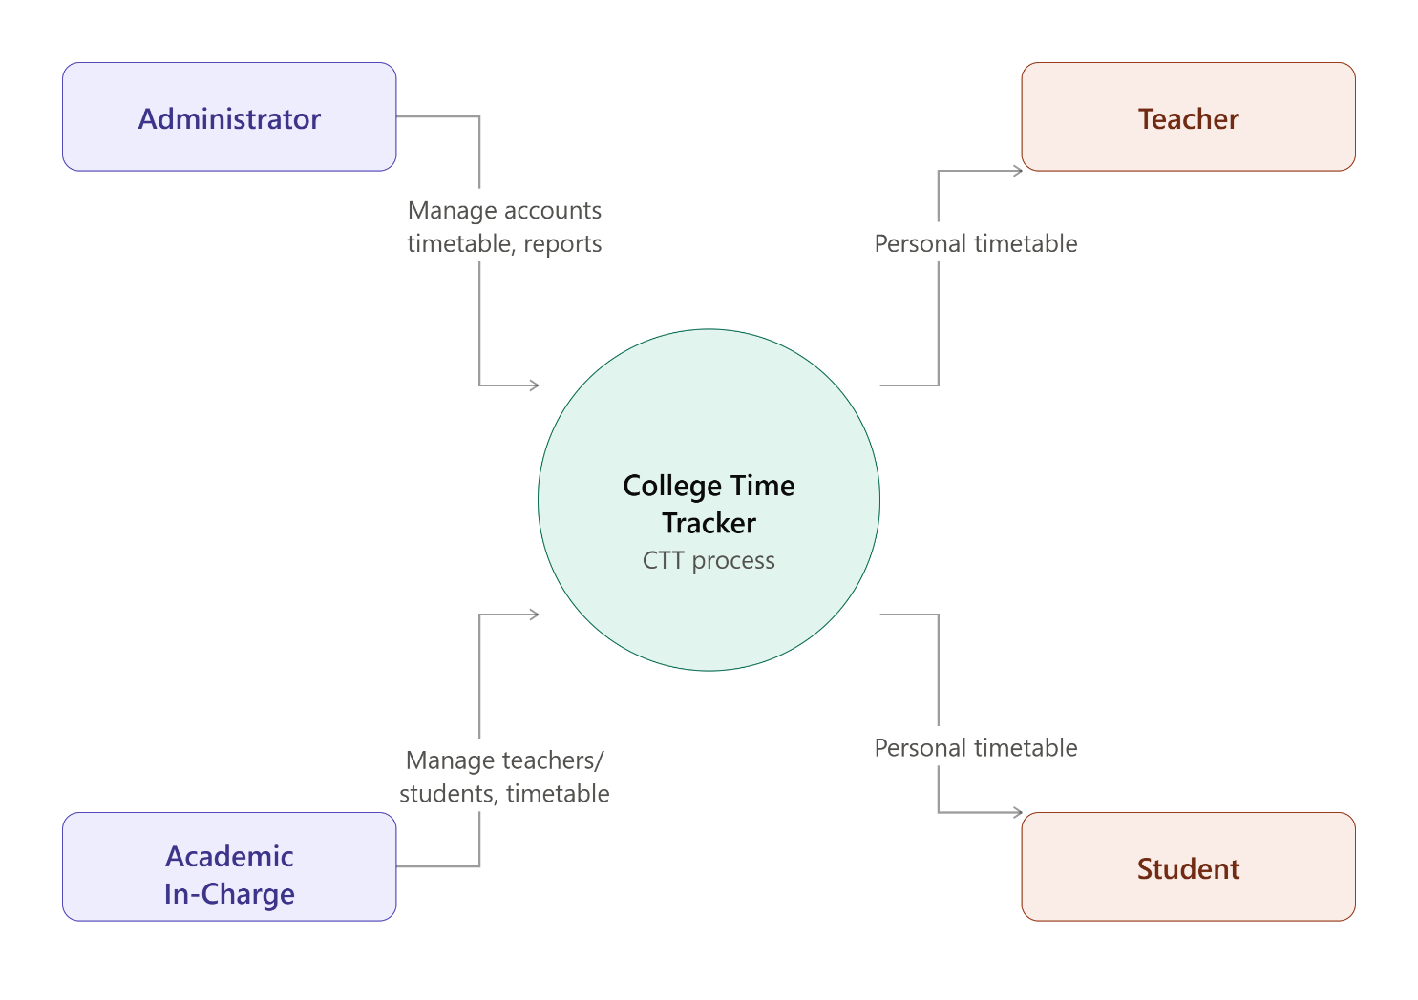
Figure 3.2: Context Level DFD (Level 0)
2. Level 1 DFD
The internal processes of the CTT system into five main functions, showing how data flows between actors, processes, and data stores.
- Process 1.0 – Manage Users: The Administrator sends account management requests to this process, which writes user data to the D1 Users data store. This includes creating and managing accounts for teachers, students, and in-charges.
- Process 2.0 – Manage Academic Entities: The Academic In-Charge manages entities such as programs, classes, subjects, and rooms. This process writes all academic data to the D2 data store (Programs / Classes / Subjects / Rooms).
- Process 3.0 – Build Timetable + Conflict Check: Admin and In-Charge provide timetable input to this process. It writes timetable data to the D3 Timetable data store and also performs automatic conflict detection to prevent scheduling errors.
- Process 4.0 – View Personal Timetable: Teachers and Students send view requests to this process, which reads data from the D3 Timetable data store and returns the relevant personal timetable to each user.
- Process 5.0 – Generate Reports: This process reads data from both D2 and D3 data stores and generates reports for Admin and In-Charge, providing a complete overview of academic and timetable information.

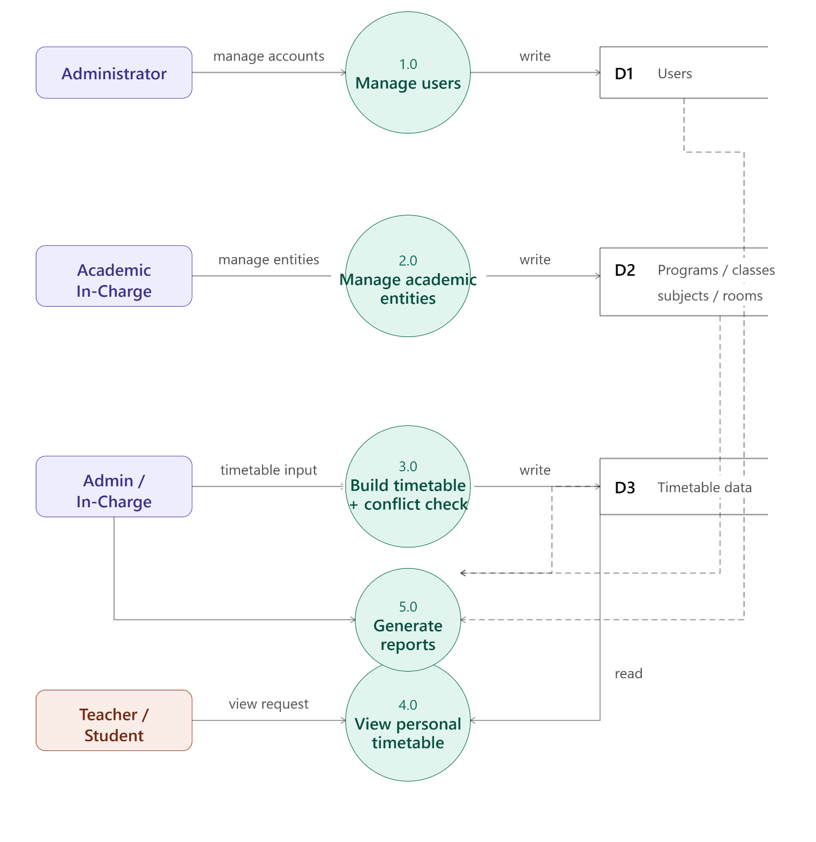
Figure 3.3: Level 1 DFD

3.3 Entity Relationship Diagram

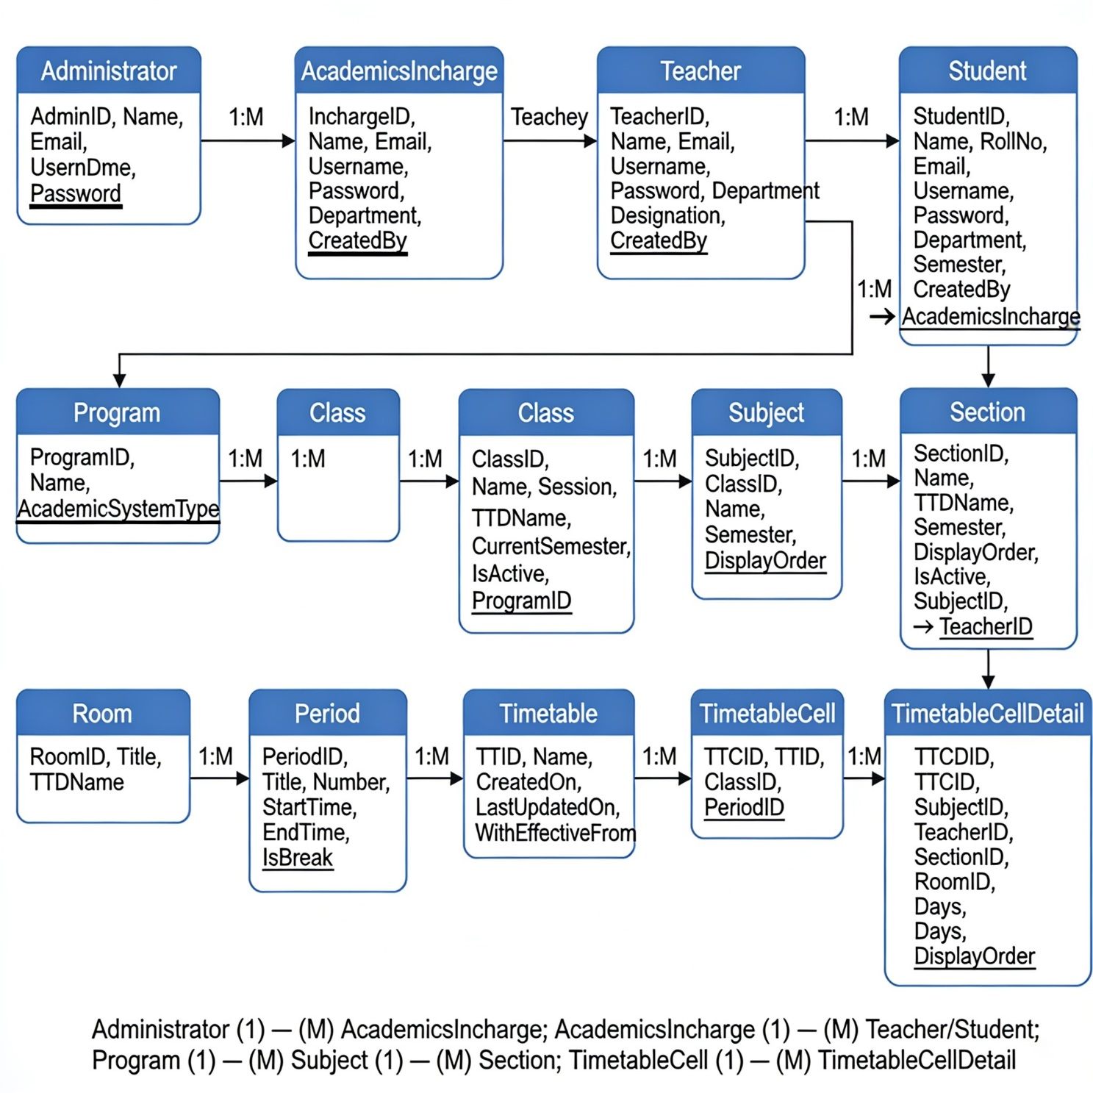
Figure 3.4: Entity Relationship Diagram

Key Entities, Attributes, Primary Keys (underlined), and Foreign Keys:
Entity | Attributes | PK | FK | Relationship
Administrator | AdminID, Name, Email, Username, Password | AdminID | — | 1:M → AcademicsIncharge
AcademicsIncharge | InchargeID, Name, Email, Username, Password, Department, CreatedBy | InchargeID | CreatedBy → Administrator | 1:M → Teacher, Student
Teacher | TeacherID, Name, Email, Username, Password, Department, Designation, CreatedBy | TeacherID | CreatedBy → AcademicsIncharge | 1:M → Section
Student | StudentID, Name, RollNo, Email, Username, Password, Department, Semester, CreatedBy | StudentID | CreatedBy → AcademicsIncharge | —
Program | ProgramID, Name, AcademicSystemType | ProgramID | — | 1:M → Class
Class | ClassID, Name, Session, TTDName, CurrentSemester, IsActive, ProgramID | ClassID | ProgramID → Program | 1:M → Subject
Subject | SubjectID, ClassID, Name, Semester, DisplayOrder | SubjectID | ClassID → Class | 1:M → Section
Section | SectionID, Name, TTDName, Semester, DisplayOrder, IsActive, SubjectID, TeacherID | SectionID | SubjectID → Subject, TeacherID → Teacher | M:1
Room | RoomID, Title, TTDName | RoomID | — | 1:M → TimetableCellDetail
Period | PeriodID, Title, Number, StartTime, EndTime, IsBreak | PeriodID | — | 1:M → TimetableCell
Timetable | TTID, Name, CreatedOn, LastUpdatedOn, WithEffectiveFrom | TTID | — | 1:M → TimetableCell
TimetableCell | TTCID, TTID, ClassID, PeriodID | TTCID | TTID, ClassID, PeriodID | 1:M → TimetableCellDetail
TimetableCellDetail | TTCDID, TTCID, SubjectID, TeacherID, SectionID, RoomID, Days, DisplayOrder | TTCDID | TTCID, SubjectID, TeacherID, SectionID, RoomID | M:1
Cardinalities: Administrator (1) — (M) AcademicsIncharge; AcademicsIncharge (1) — (M) Teacher/Student; Program (1) — (M) Class (1) — (M) Subject (1) — (M) Section; TimetableCell (1) — (M) TimetableCellDetail.

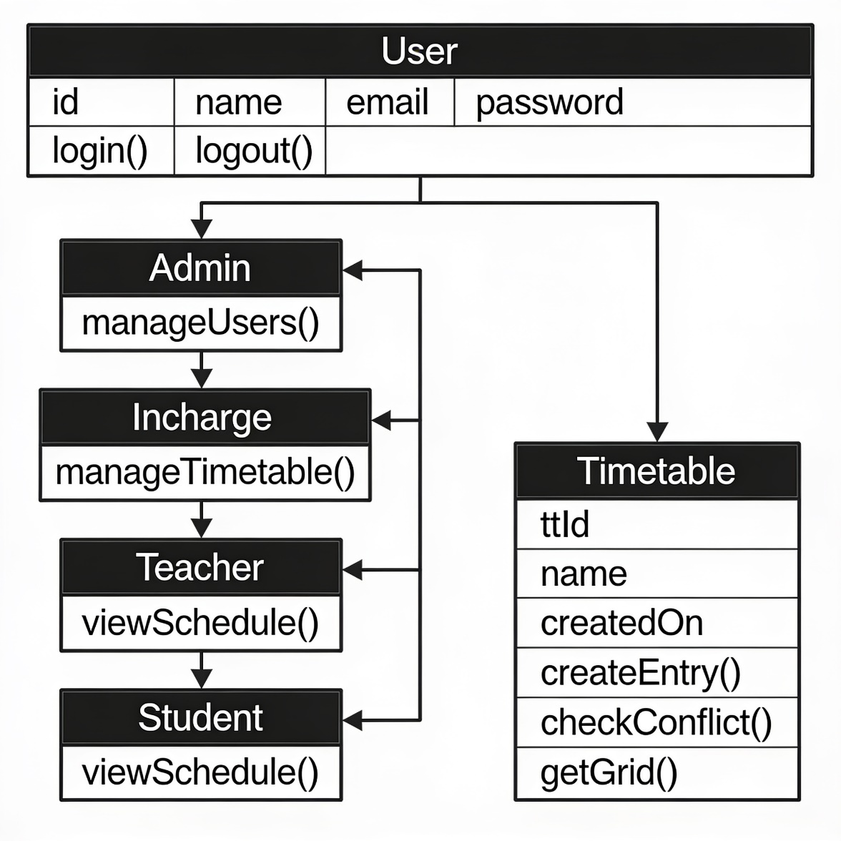
3.4 UML Diagrams

Figure 3.5: Class Diagram (Key Classes)

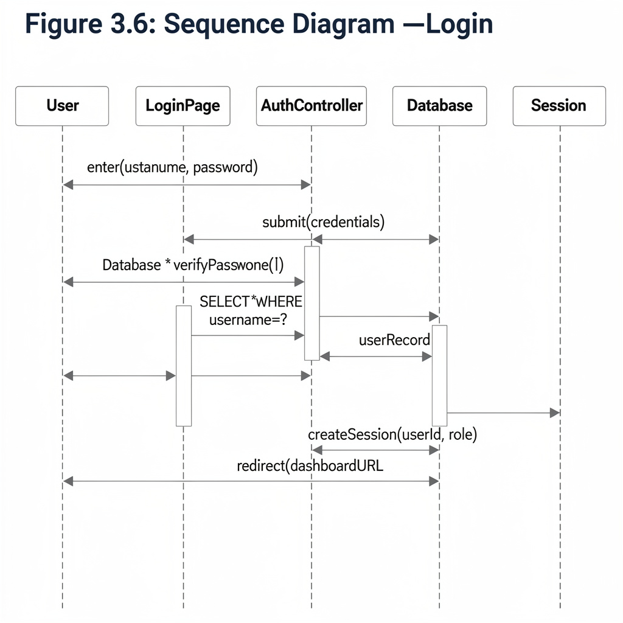
Figure 3.6: Sequence Diagram — Login
Description
User → LoginPage: enter(username, password)
LoginPage → AuthController: submit(credentials)
AuthController → Database: SELECT * WHERE username=?
Database → AuthController: userRecord
AuthController → AuthController: verifyPassword()
AuthController → Session: createSession(userId, role)
AuthController → LoginPage: redirect(dashboardURL)
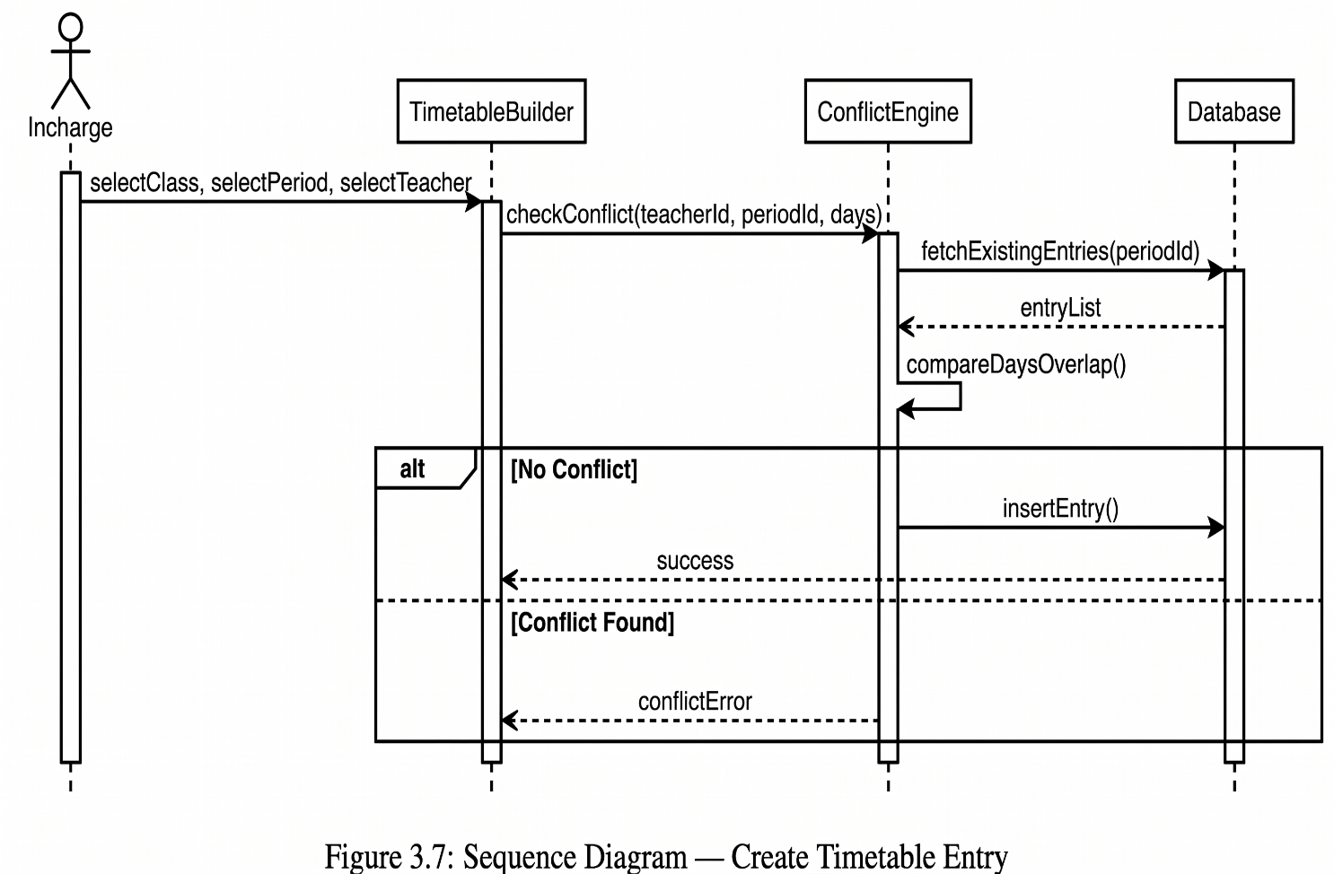
Figure 3.7: Sequence Diagram — Create Timetable Entry
Description
Incharge → TimetableBuilder: selectClass, selectPeriod, selectTeacher
TimetableBuilder → ConflictEngine: checkConflict(teacherId, periodId, days)
ConflictEngine → Database: fetchExistingEntries(periodId)
Database → ConflictEngine: entryList
ConflictEngine → ConflictEngine: compareDaysOverlap()
If No Conflict: ConflictEngine → Database: insertEntry(); Database → TimetableBuilder: success
If Conflict Found: ConflictEngine → TimetableBuilder: conflictError

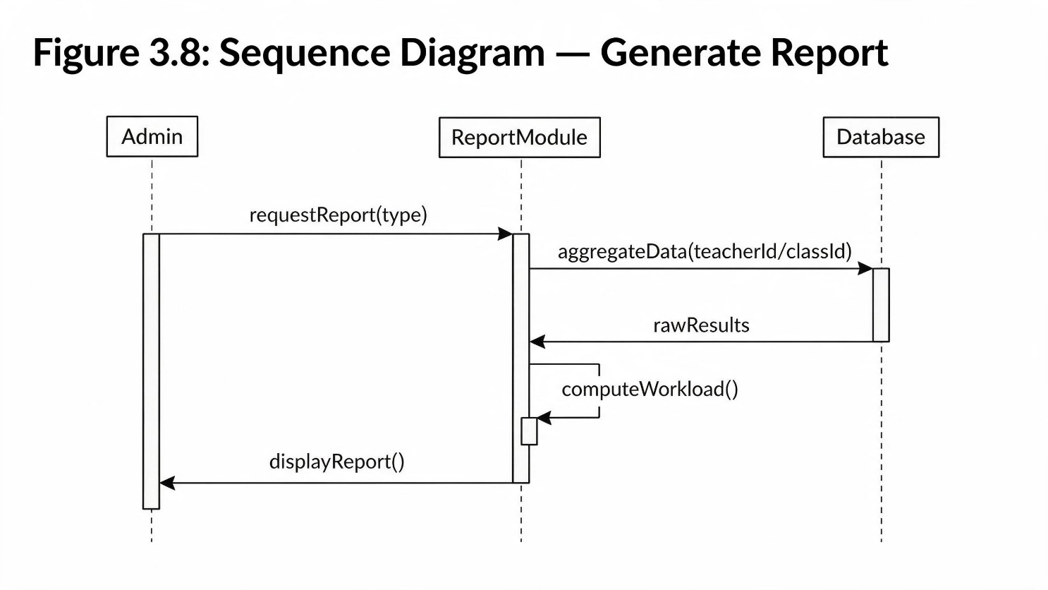
Figure 3.8: Sequence Diagram — Generate Report
Description
Admin → ReportModule: requestReport(type)
ReportModule → Database: aggregateData(teacherId/classId)
Database → ReportModule: rawResults
ReportModule → ReportModule: computeWorkload()
ReportModule → Admin: displayReport()
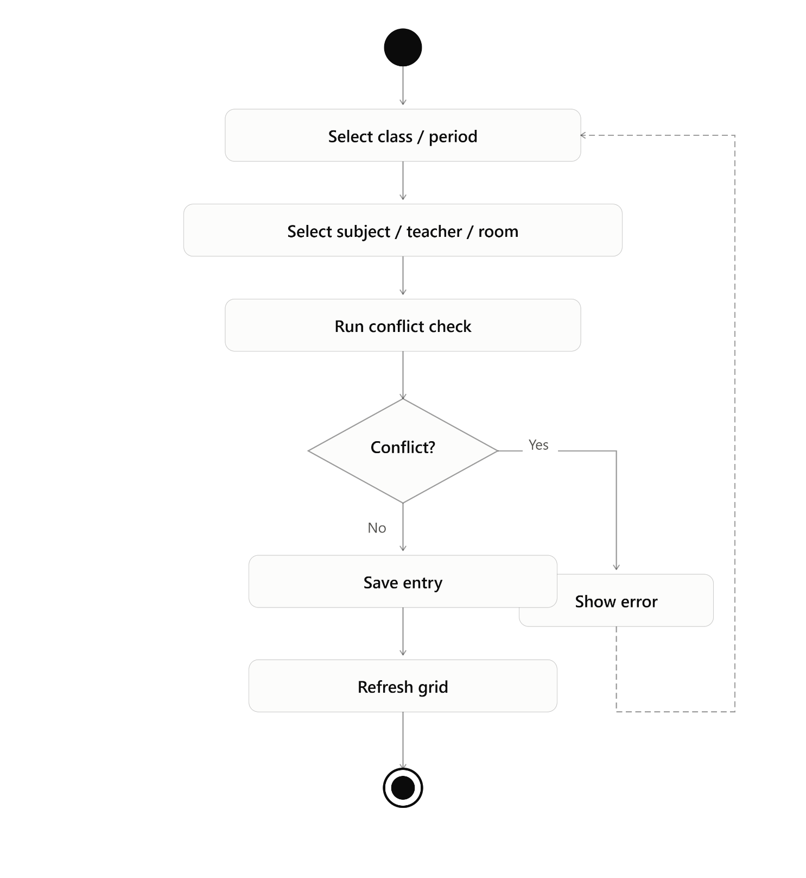
Figure 3.9: Activity Diagram — Timetable Creation

3.5 Database Design
Table 3.1: Database Tables Description
Table Name | Field Name | Data Type | Description
administrator | AdminID | INT (PK) | Unique admin identifier
administrator | Username | VARCHAR(50) | Login username
administrator | Password | VARCHAR(255) | Hashed password
academicsincharge | InchargeID | INT (PK) | Unique in-charge identifier
academicsincharge | CreatedBy | INT (FK) | References Administrator
teacher | TeacherID | INT (PK) | Unique teacher identifier
teacher | Designation | VARCHAR(100) | Teacher's academic designation
student | StudentID | INT (PK) | Unique student identifier
student | RollNo | VARCHAR(50) | Student roll number
timetable | TTID | INT (PK) | Timetable record identifier
timetablecell | TTCID | INT (PK) | Grid cell identifier
timetablecell | ClassID | INT (FK) | References Class
timetablecell | PeriodID | INT (FK) | References Period
timetablecelldetail | TTCDID | INT (PK) | Cell-detail identifier
timetablecelldetail | Days | VARCHAR(50) | Days pattern (e.g., MO-TU-WE)

Administrator Table 3.1
Field | Type | Description
AdminID PK | int(11) | Unique administrator ID
Name | varchar(100) | Full name
Email | varchar(100) | Unique email
Username | varchar(50) | Login username
Password | varchar(255) | Encrypted password

AcademicsIncharge Table 3.2
Field | Type | Description
InchargeID PK | int(11) | Unique ID
Name | varchar(100) | Full name
Email | varchar(100) | Unique email
Username | varchar(50) | Login username
Password | varchar(255) | Encrypted password
Department | varchar(100) | Assigned department
CreatedBy FK | int(11) | References AdminID

Program Table 3.3
Field | Type | Description
ProgramID PK | int(11) | Unique program ID
Name | varchar(100) | Program name (BSCS, BSIT…)
AcademicSystemType | varchar(50) | Semester / annual

Class Table 3.4
Field | Type | Description
ClassID PK | int(11) | Unique class ID
Name | varchar(100) | Class name
Session | varchar(50) | Academic session
TTDName | varchar(50) | Timetable display name
CurrentSemester | varchar(50) | Current semester
IsActive | tinyint(1) | Active / inactive status
ProgramID FK | int(11) | References Program

Teacher Table 3.5
Field | Type | Description
TeacherID PK | int(11) | Unique teacher ID
Name | varchar(100) | Teacher name
Email | varchar(100) | Unique email
Username | varchar(50) | Login username
Password | varchar(255) | Encrypted password
Department | varchar(100) | Department name
Designation | varchar(100) | Academic designation
CreatedBy FK | int(11) | References InchargeID
MaxHoursPerDay | int(11) | Max teaching hours/day

Student Table 3.6
Field | Type | Description
StudentID PK | int(11) | Unique student ID
Name | varchar(100) | Student name
RollNo | varchar(50) | Unique roll number
Email | varchar(100) | Unique email
Username | varchar(50) | Login username
Password | varchar(255) | Encrypted password
Department | varchar(100) | Department name
Semester | varchar(50) | Current semester
CreatedBy FK | int(11) | References InchargeID

Subjects Table 3.7
Field | Type | Description
SubjectID PK | int(11) | Unique subject ID
ClassID FK | int(11) | References Class
Name | varchar(100) | Subject name
Semester | varchar(50) | Assigned semester
DisplayOrder | int(11) | Display sequence
WeeklyHours | int(11) | Weekly lecture hours
IsLab | tinyint(1) | Lab subject indicator

Section Table 3.8
Field | Type | Description
SectionID PK | int(11) | Unique section ID
Name | varchar(100) | Section name
TTDName | varchar(50) | Timetable display name
Semester | varchar(50) | Semester
DisplayOrder | int(11) | Display order
IsActive | tinyint(1) | Active status
SubjectID FK | int(11) | References Subject
TeacherID FK | int(11) | References Teacher

Room Table 3.9
Field | Type | Description
RoomID PK | int(11) | Unique room ID
Title | varchar(50) | Room name / number
TTDName | varchar(50) | Timetable display name
IsLab | tinyint(1) | Lab room indicator

Period Table 3.10
Field | Type | Description
PeriodID PK | int(11) | Unique period ID
Title | varchar(50) | Period title
Number | int(11) | Period number
StartTime | time | Start time
EndTime | time | End time
FridayStartTime | time | Friday start time
FridayEndTime | time | Friday end time
IsZeroPeriod | tinyint(1) | Zero period indicator
IsBreak | tinyint(1) | Break indicator
DisplayOrder | int(11) | Display order

TimeTable Table 3.11
Field | Type | Description
TTID PK | int(11) | Timetable record ID
Name | varchar(100) | Timetable name
CreatedOn | date | Creation date
LastUpdatedOn | date | Last updated date
WithEffectiveFrom | date | Effective from date

TimetableCell Table 3.12
Field | Type | Description
TTCID PK | int(11) | Grid cell ID
TTID FK | int(11) | References TimeTable
ClassID FK | int(11) | References Class
PeriodID FK | int(11) | References Period

TimetableCellDetail Table 3.13
Field | Type | Description
TTCDID PK | int(11) | Cell-detail ID
TTCID FK | int(11) | References TimetableCell
SubjectID FK | int(11) | References Subject
TeacherID FK | int(11) | References Teacher
SectionID FK | int(11) | References Section
RoomID FK | int(11) | References Room
Days | varchar(20) | Day pattern (e.g. MO-TU-WE)
DisplayOrder | int(11) | Display sequence

3.6 User Interface Design
- Wireframes: Home page → Login page → Role Dashboard → Timetable Grid → Management forms.
- Mockups: Centered card-based login form; sidebar navigation dashboard layout; grid-based timetable view color-coded by class.
- Navigation Structure: Top-level: Home → Login/Register. After login: Sidebar → Dashboard, User Management, Academic Entities, Timetable Builder, Reports.

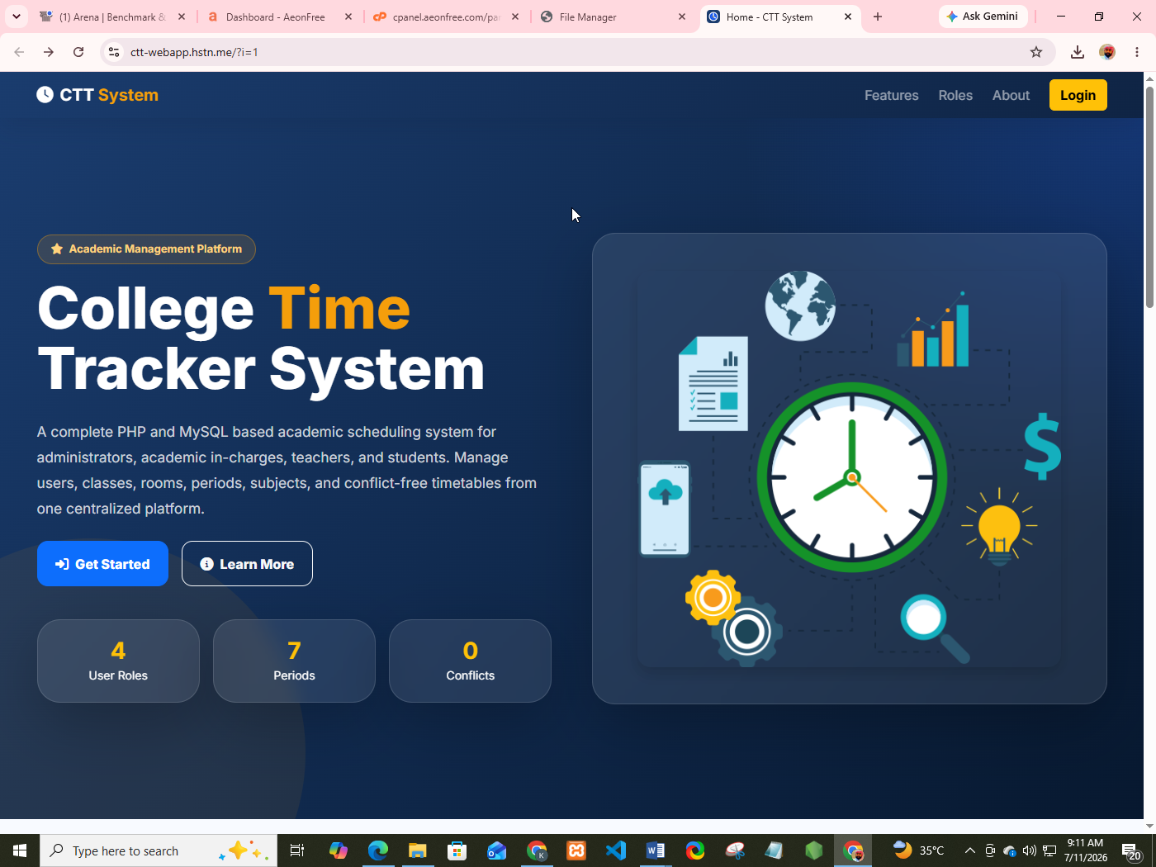
Home page
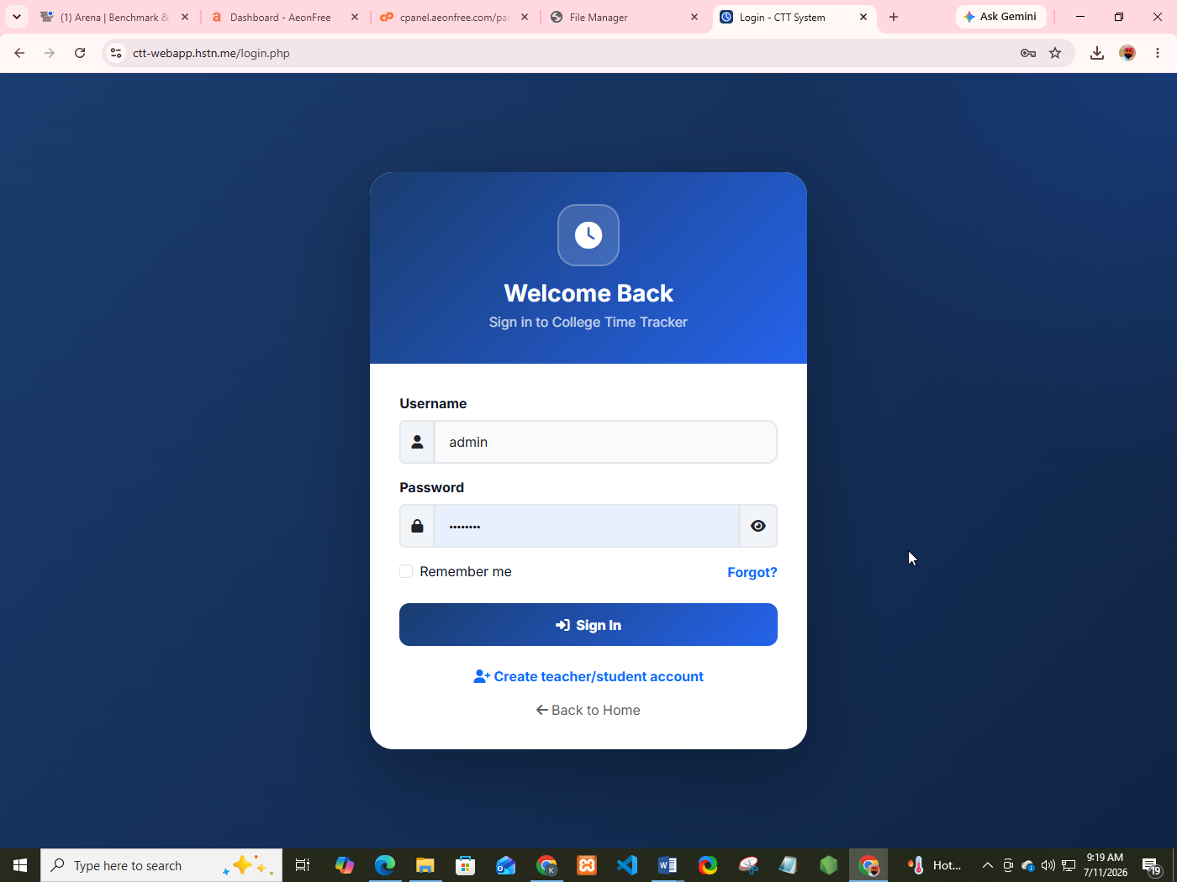
Login page

Role Dashboard
- Admin Dashboard

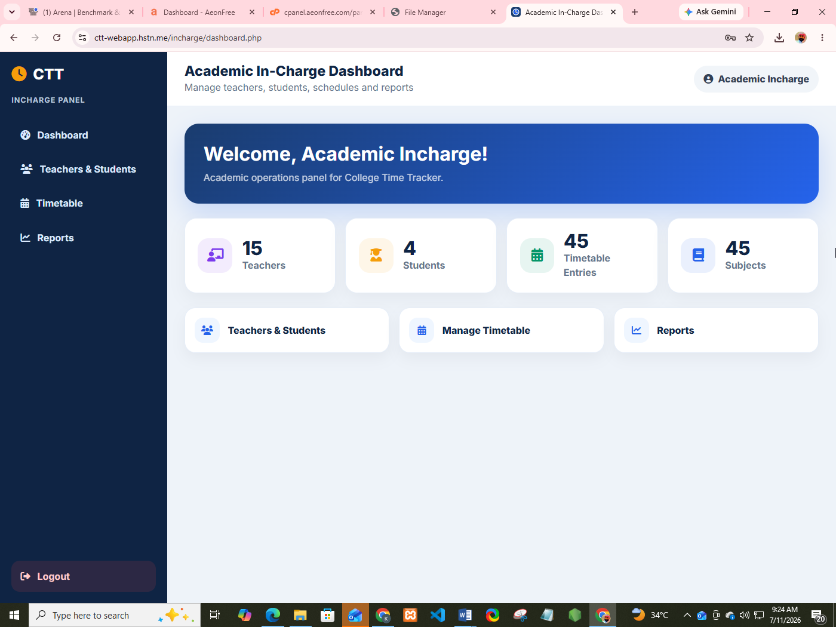
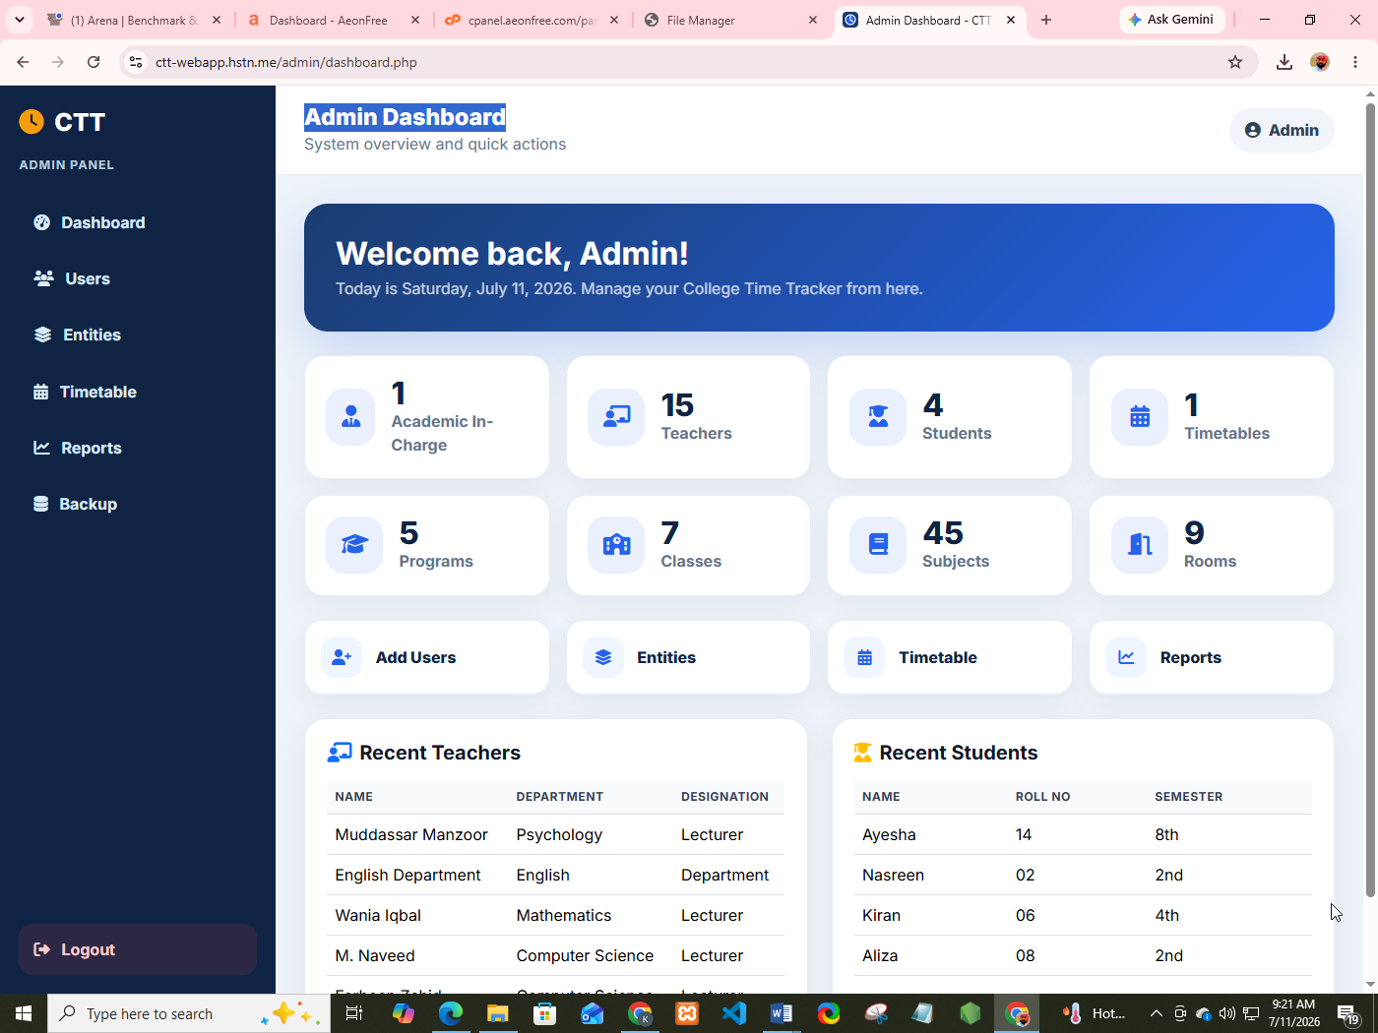
- Academic In-Charge Dashboard

- Teacher Dashboard

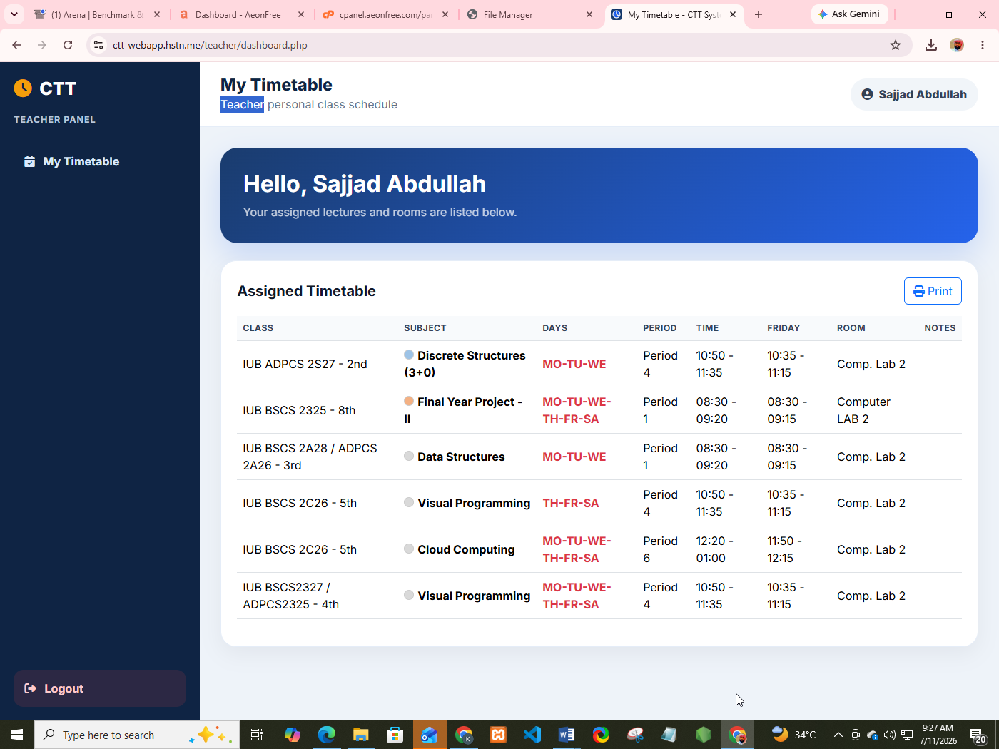
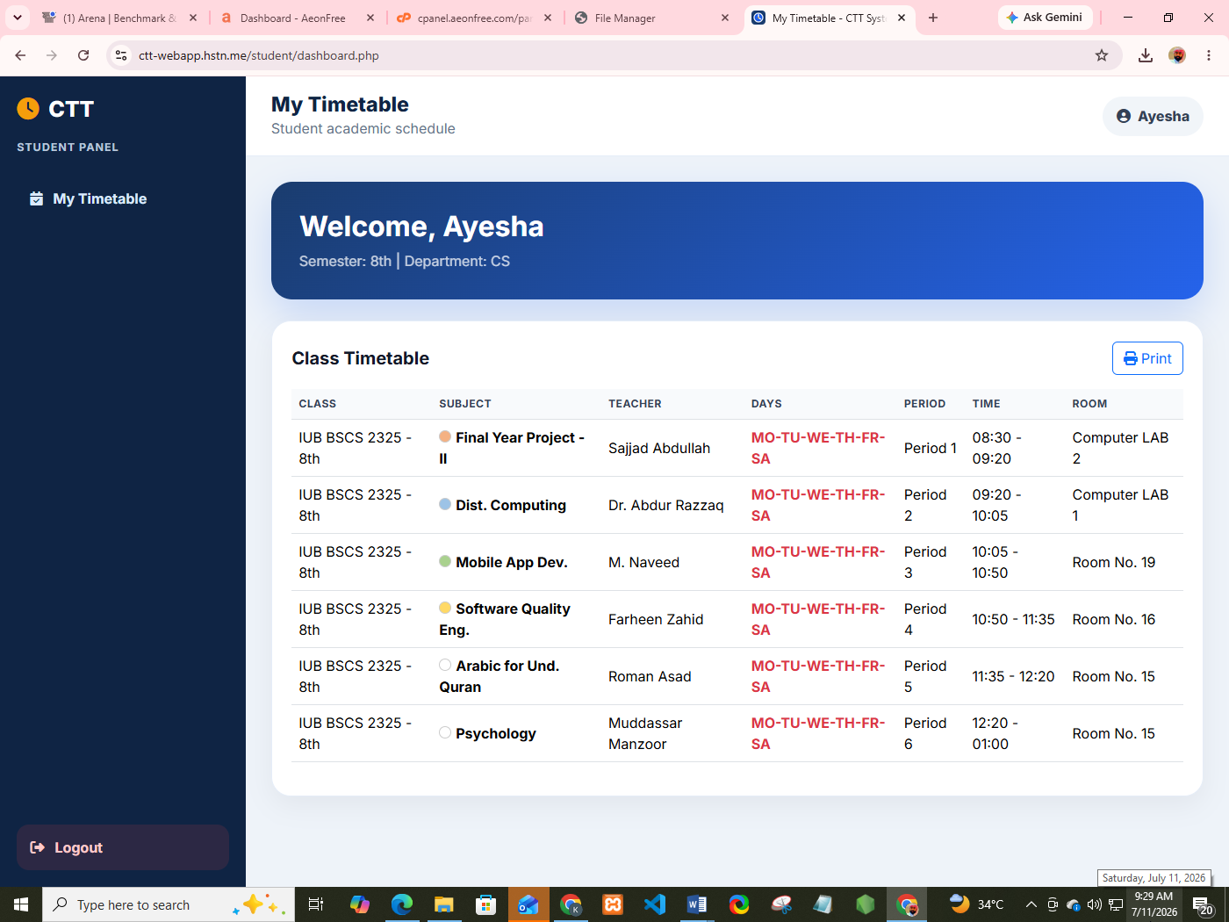
- Student Dashboard

Chapter 4:

Development

4.1 Development Environment
Item | Detail
Operating System | Windows 10/11
IDE | Visual Studio Code
Local Server | XAMPP (Apache + MySQL + PHP 8.x)
Version Control | Git / GitHub
Browser Testing | Google Chrome, Mozilla Firefox

4.2 System Modules

4.2.1 Authentication Module
- Purpose: Validate user credentials and establish a role-based session.
- Input: Username, Password.
- Output: Authenticated session redirecting to the correct dashboard.

4.2.2 Admin Module
- Purpose: Allow the Administrator to manage Academic In-Charge accounts and system-wide settings.
- Input: In-Charge details (Name, Email, Department).
- Output: Updated user list with confirmation message.

4.2.3 Timetable Module
- Purpose: Build and manage the master timetable grid with conflict prevention.
- Input: Class, Period, Subject, Teacher, Room, Section, Days.
- Output: Updated timetable grid, or a conflict error message.

4.2.4 Reporting Module
- Purpose: Generate teacher workload and class-load summaries.
- Input: Date range / filter criteria.
- Output: Tabular report, exportable to CSV.

4.3 Key Implementation Details
Conflict Detection Algorithm: Before inserting a new timetable entry, the system retrieves all existing entries for the same Period, filters those with a different Class, and checks whether the assigned Teacher matches and whether the Days values share any overlapping day token (e.g., “MO”). If both conditions are true, the entry is rejected.

4.3.1 Description of the Conflict Check Logic
This subsection explains, in narrative form and without displaying a code listing, exactly how the conflict-checking routine referred to in the system as hasConflict() behaves. The purpose of this explanation is to describe the same logic that was originally implemented as a PHP function, but expressed entirely as descriptive text so that a reader unfamiliar with PHP syntax can still understand precisely what the routine checks, in what order, and why each step is necessary. No behavior described below has been altered from the original implementation; only the presentation has changed from a code block to a detailed written explanation.
Purpose of the routine. The routine exists to answer a single yes/no question before any timetable entry is written to the database: “Is the teacher who is about to be assigned to this class, during this period, on these days, already teaching a different class at an overlapping time?” If the answer is yes, the routine reports that a conflict exists and the calling code must refuse to save the new entry. If the answer is no, the routine reports that no conflict exists and the calling code is free to proceed with the insert or update operation.
Inputs accepted by the routine. The routine accepts four pieces of information every time it is invoked, together with an active database connection so that it can query the underlying tables:
The identifier of the Teacher who is being assigned to the new entry (referred to as the Teacher ID).
The identifier of the Period in which the new entry is being placed (referred to as the Period ID), since a conflict can only occur when two entries fall in the same period slot.
The Days value associated with the new entry — a short text pattern such as “MO-TU-WE” that lists, using two-letter abbreviations separated by hyphens, which days of the week the class meets during that period.
The identifier of the Class that is currently being edited (referred to as the excluded Class ID), which is used so that the routine does not mistakenly flag the entry currently being edited as a conflict with itself.
Step 1 — Breaking the Days pattern into individual day tokens. The first action the routine takes is to split the Days text supplied for the new entry wherever a hyphen character appears. For example, the pattern “MO-TU-WE” is broken into three separate tokens: “MO”, “TU”, and “WE”. This step is necessary because a class does not always meet on a single day; many classes recur on two or three days within the same period slot, and the conflict check must be able to compare each individual day separately rather than treating the whole pattern as one indivisible string.
Step 2 — Retrieving all existing entries that could possibly conflict. The routine next queries the database for every row already stored in the timetable-cell-detail table that is linked, through the timetable-cell table, to the same Period ID that was supplied as input, and that was created by the same Teacher ID that was supplied as input. Critically, the query also excludes any existing rows that belong to the same Class ID that is currently being edited, because it would be incorrect to flag an existing entry as a conflict with itself when a user is simply updating or re-saving an entry that already belongs to that class. In effect, this step gathers a candidate list containing only those existing timetable rows where the same teacher is already committed to teaching a different class during the same period slot.
Step 3 — Comparing day patterns for overlap. For every row returned by the database query in Step 2, the routine repeats the same splitting operation described in Step 1, breaking that existing row's stored Days value into its own list of individual day tokens. It then compares the list of day tokens belonging to the new entry against the list of day tokens belonging to each existing row, looking specifically for any day token that appears in both lists. This comparison is what technically corresponds to computing the intersection of the two token sets: if the intersection is empty, the two entries never actually meet on the same calendar day even though they share the same period slot, and therefore there is no real scheduling clash; if the intersection contains at least one shared day token, then the teacher would genuinely be required to be in two different classrooms at the same time on that day, which is precisely the situation the system must prevent.
Step 4 — Reaching a verdict. As soon as the routine finds one existing row whose day tokens overlap with the new entry's day tokens, it immediately concludes that a conflict has been found and reports this outcome back to the calling code without needing to examine any further rows, since a single genuine overlap is sufficient to reject the new entry. If the routine finishes comparing the new entry against every candidate row retrieved in Step 2 and never finds an overlapping day token, it reports that no conflict was found, and the calling code is then permitted to insert the new timetable entry into the database.
Why each safeguard matters. Restricting the database query to the same Period ID ensures the routine never wastes time comparing entries that occur at completely different times of day, which could never conflict regardless of which days they fall on. Restricting the query to the same Teacher ID ensures the routine only raises an alarm when the actual constraint the college cares about — a single teacher physically being in two places at once — is genuinely at risk of being violated; two different teachers can freely be scheduled in the same period without any conflict. Excluding the Class ID currently being edited prevents the system from generating a false-positive conflict against the very entry the user is in the process of saving or updating. Finally, comparing day tokens individually, rather than comparing the full Days string for exact equality, correctly handles the common real-world case where two classes share only some, but not all, of their meeting days within the same period.
Outcome for the user. When the routine reports that a conflict exists, the Timetable Builder module displays a clear, human-readable error message to the Administrator or Academic In-Charge, identifying that the selected teacher is already committed elsewhere at an overlapping day and period, and the new entry is not written to the database. When the routine reports that no conflict exists, the Timetable Builder proceeds to save the new entry, and the weekly timetable grid is refreshed on screen to display the newly added Subject, Teacher, Room, Section, and Days combination in the appropriate cell.

4.3.2 Validation Logic
Server-side validation checks required fields, unique username/email constraints, and correct data types before any INSERT/UPDATE query executes.

4.3.3 Business Rule
A user account created by an Academic In-Charge cannot elevate its own role; only an Administrator may create In-Charge accounts.

4.4 APIs / Third-Party Integrations
No external third-party APIs are used in the core system. Bootstrap 5 and Font Awesome are included via CDN for UI styling and iconography only.

Chapter 5:

Software Testing

5.1 Testing Strategy
- Unit Testing: Individual PHP functions (e.g., password hashing, conflict check) tested in isolation.
- Integration Testing: Verified that the Timetable Builder correctly interacts with the Conflict Engine and Database layer.
- System Testing: Full end-to-end testing of all modules together.
- Acceptance Testing: Conducted with sample users (a mock Admin, In-Charge, Teacher, Student) to confirm the system meets requirements.

5.2 Test Plan
- Objective: Verify that all functional requirements (FR-01 to FR-17) behave correctly under normal, invalid, and boundary conditions.
- Scope: All modules — Authentication, User Management, Academic Entities, Timetable Builder, Reports.
- Approach: Manual black-box testing using a structured test case document.

5.3 Test Cases
Table 5.1: Test Cases
Test ID | Description | Input | Expected Output | Status
TC-01 | Valid Admin login | admin / correct password | Redirect to Admin Dashboard | Pass
TC-02 | Invalid password login | admin / wrong password | "Invalid username or password" | Pass
TC-03 | Empty login fields | "" / "" | "Please fill in all fields" | Pass
TC-04 | Add new Teacher | Valid teacher details | Teacher added, confirmation shown | Pass
TC-05 | Add Teacher with duplicate email | Existing email | "Email already exists" | Pass
TC-06 | Add Student with missing Roll No | Blank RollNo | "Roll Number is required" | Pass
TC-07 | Create timetable entry (no conflict) | Unique teacher/period | Entry saved | Pass
TC-08 | Create timetable entry (conflict) | Same teacher, overlapping day, different class | "Conflict detected" error | Pass
TC-09 | Delete timetable entry | Valid entry ID | Entry removed from grid | Pass
TC-10 | View personal timetable (Teacher) | Logged in as Teacher | Only teacher's own classes shown | Pass
TC-11 | View personal timetable (Student) | Logged in as Student | Only student's class shown | Pass
TC-12 | Access Admin page as Student | Student session, Admin URL | Redirected to Student dashboard | Pass
TC-13 | Password field boundary (5 characters) | "abcde" | "Password must be at least 6 characters" | Pass
TC-14 | Password field boundary (6 characters) | "abcdef" | Accepted | Pass
TC-15 | Generate teacher workload report | Valid request | Report table displayed | Pass
TC-16 | Export timetable to CSV | Click Export | CSV file downloaded | Pass
TC-17 | Print timetable | Click Print | Print-friendly layout shown | Pass
TC-18 | SQL Injection attempt in login | ' OR '1'='1 | Login rejected, no bypass | Pass
TC-19 | Add Room with duplicate title | Existing room title | Room still added / warning | Pass
TC-20 | Session expiry after logout | Logout action | Redirect to login, session cleared | Pass
Additional boundary/negative cases were tested for each CRUD module following the same pattern, totaling 20+ test cases.

5.4 Black Box Testing
Black-box testing was performed on all user-facing forms (login, registration, timetable builder) without inspecting internal code, focusing on input/output correctness relative to functional requirements.

5.6 Bug Reports
Bug ID | Description | Severity | Status
BUG-01 | Timetable grid did not refresh immediately after adding an entry | Medium | Fixed
BUG-02 | Duplicate room names were allowed | Low | Fixed
BUG-03 | Session did not expire after prolonged inactivity | Medium | Fixed

Chapter 6:

Implementation

6.1 Hardware Requirements
- Processor: Dual-core 2 GHz or higher
- RAM: 4 GB minimum
- Storage: 500 MB free disk space

6.2 Software Requirements
- Operating System: Windows 10/11 or Linux
- XAMPP (Apache, MySQL, PHP 8.x)
- Modern web browser (Chrome, Firefox, Edge)

6.3 Installation Procedure
Step 1: Install XAMPP and start the Apache and MySQL services.
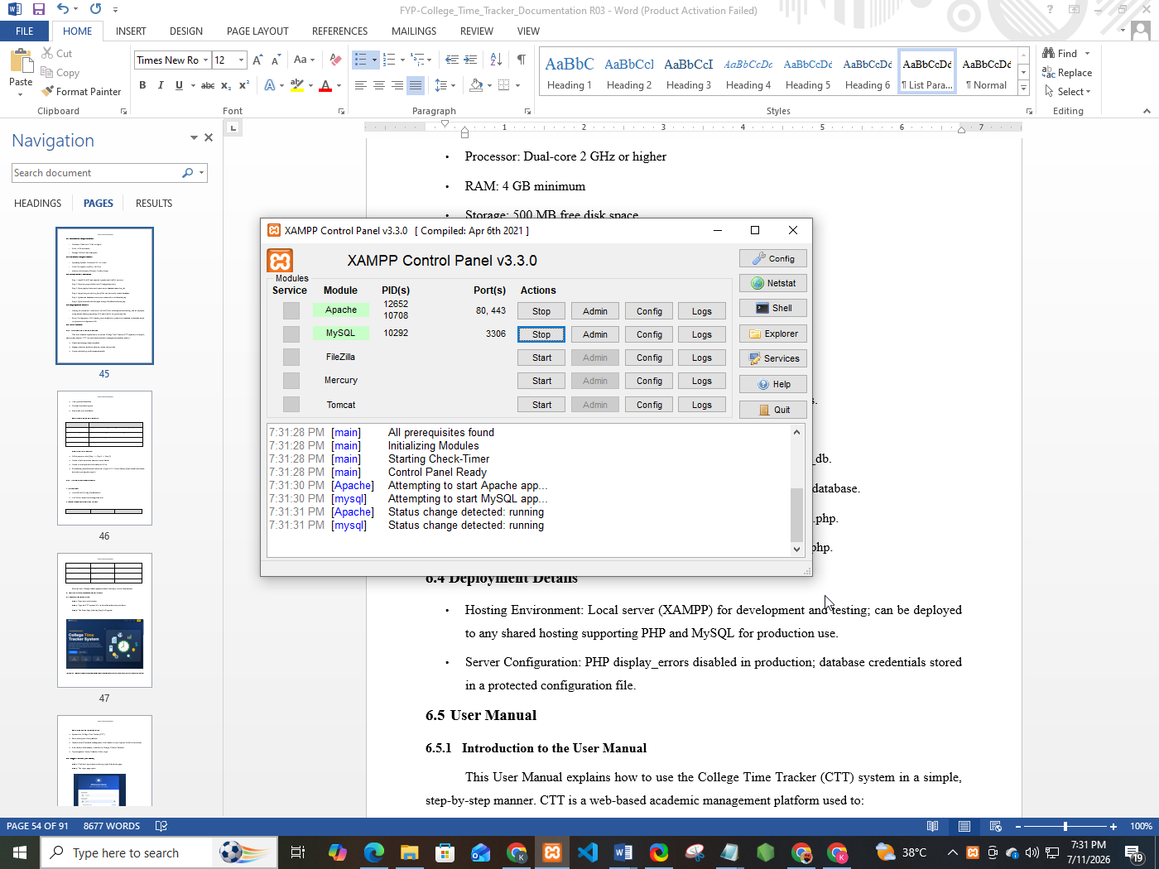
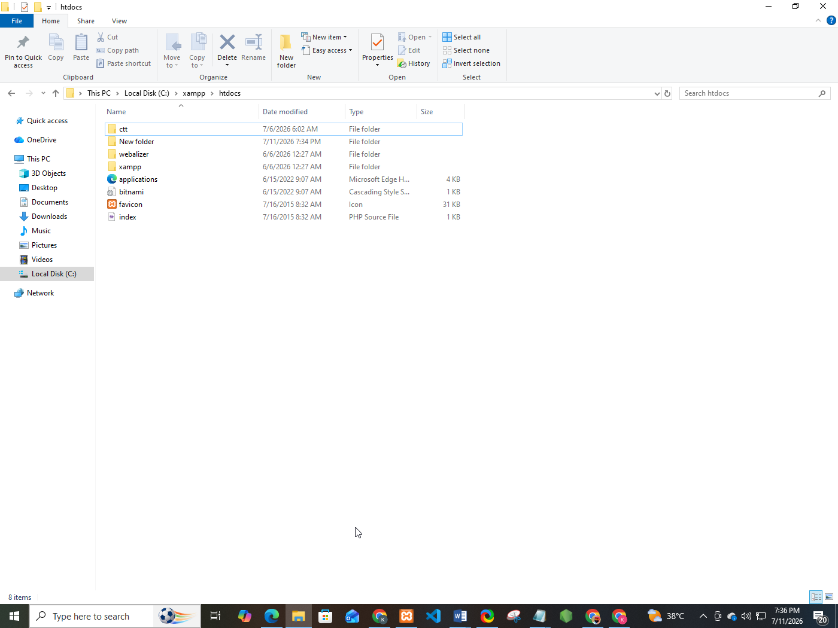
Step 2: Copy the project folder into C:\xampp\htdocs\ctt.

Step 3: Open phpMyAdmin and create a new database named ctt_db.
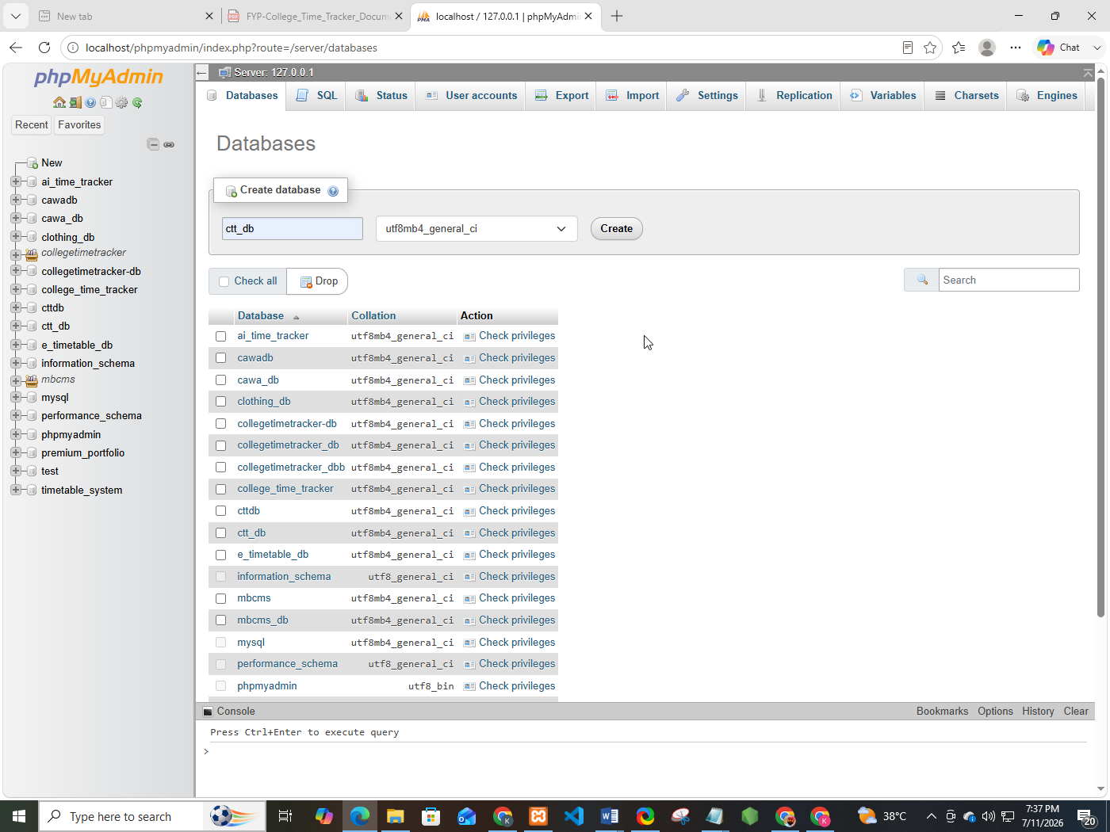
Step 4: Import the provided ctt_db.sql file into the newly created database.
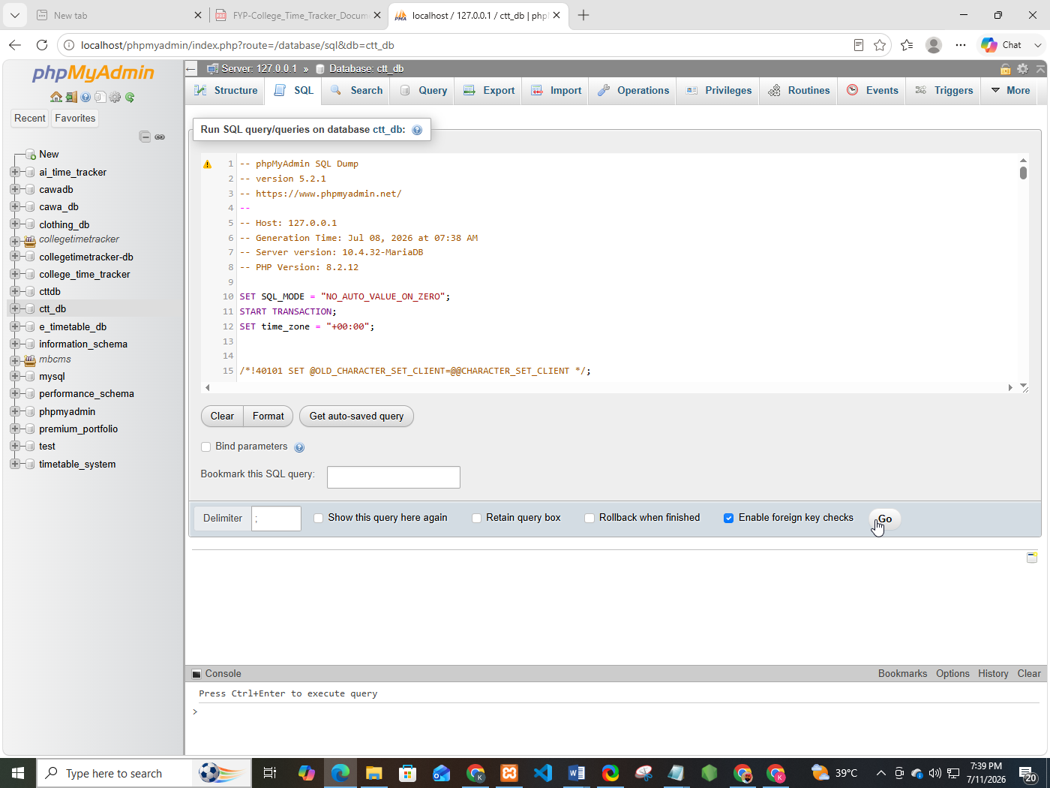

Step 5: Update the database connection credentials in includes/db.php.
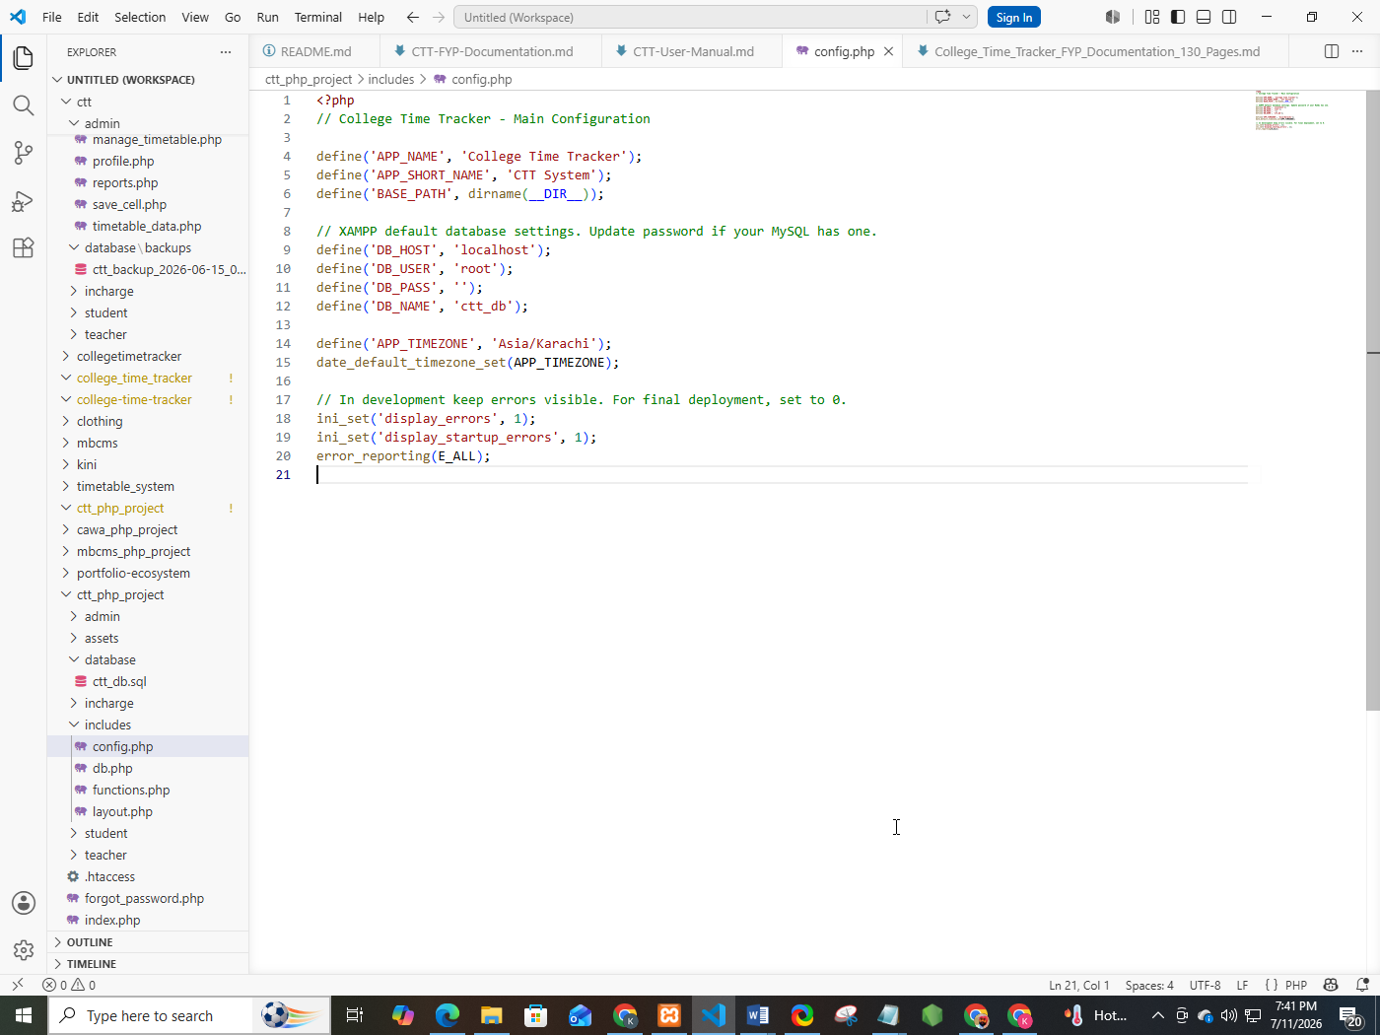
Step 6: Open a browser and navigate to http://localhost/ctt/index.php.
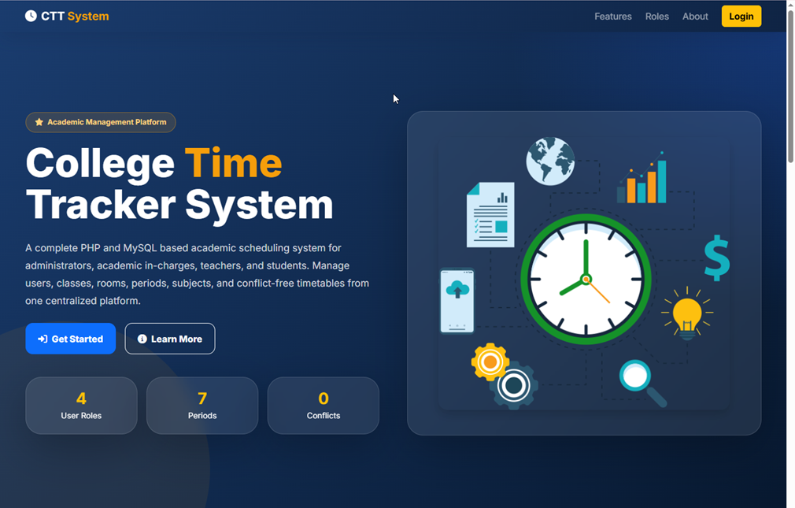

6.4 Deployment Details
- Hosting Environment: Local server (XAMPP) for development and testing; can be deployed to any shared hosting supporting PHP and MySQL for production use.
- Server Configuration: PHP display_errors disabled in production; database credentials stored in a protected configuration file.

User Manual

6.5.1 Introduction to the User Manual
This User Manual explains how to use the College Time Tracker (CTT) system in a simple, step-by-step manner. CTT is a web-based academic management platform used to:
- Create and manage class timetables
- Manage teachers, students, subjects, rooms, and periods
- Prevent scheduling conflicts automatically
- View personal schedules
- Generate workload reports
- Export and print timetables

Who Should Read This Manual?
Role | Why Read This Manual?
Administrator | Full system control, manage In-Charge accounts, backups, reports
Academic In-Charge | Build timetables, manage teachers/students, assign classes
Teacher | View personal teaching schedule
Student | View personal class timetable

How to Use This Manual
- Follow steps in order (Step 1 → Step 2 → Step 3).
- Words in bold are button names or menu labels.
- Words in code style are field names or URLs.
- Screenshots placeholders are shown as: [Figure X.X: Screen Name] (Insert actual screenshot here when printing the report.)

6.5.2 System Access Requirements

1 System URL
- Local (XAMPP): http://localhost/ctt/
- Live Server: https://ctt-webapp.hstn.me/
2 Default Demo Accounts (for testing)

Role | Username | Password
Administrator | admin | 123456
Academic In-Charge | incharge | 123456
Teacher | sajjad (or other teacher username) | 123456
Student | ayesha (or other student username) | 123456

Security Note: Change default passwords after first login in a real deployment.
3. Getting Started (Common for All Users)
3.1 Opening the Application
Step 1: Open your web browser.
Step 2: Type the CTT system URL in the address bar and press Enter.
Step 3: The Home Page (Landing Page) will appear.


Figure 6.1: Home / Landing Page — Shows CTT logo, features section, user roles section, and Login button.

What You See on the Home Page
- System title: College Time Tracker (CTT)
- Short description of the platform
- Feature cards (Timetable Management, Role-Based Access, Reports, Conflict Prevention)
- Role cards (Administrator, Academic In-Charge, Teacher, Student)
- Top navigation: Home, Features, Roles, Login

3.2 Login Process (All Roles)
Step 1: Click the Login button on the top-right of the home page.
Step 2: The Login page opens.


Figure 6.2: Login Page — Centered card with Username and Password fields, Remember Me checkbox, Forgot Password link, and Sign In button.
Step 3: Enter your Username.
Step 4: Enter your Password.
Step 5: (Optional): Tick Remember Me if you want the browser to keep you logged in longer.
Step 6: Click Sign In.

What Happens After Login?
The system checks your role and redirects you automatically:
Your Role | Redirect Destination
Administrator | Admin Dashboard
Academic In-Charge | In-Charge Dashboard
Teacher | Teacher Dashboard
Student | Student Dashboard

Login Errors and Solutions
Error Message | Cause | Solution
Please fill in all fields | Empty username or password | Fill both fields
Invalid username or password | Wrong credentials | Recheck username/password
Account blocked | Admin blocked your account | Contact Administrator

3.3 Logout Process (All Roles)
Step 1: On any dashboard, look at the left Sidebar.
Step 2: Click Logout at the bottom of the sidebar.
Step 3: You will be redirected to the Login page.
Step 4: Your session is destroyed (secure logout).
Always logout when using a shared computer.
3.4 Forgot Password
Step 1: On the Login page, click Forgot Password?.
Step 2: Enter your registered Email Address.
Step 3: Select your Role (Admin / In-Charge / Teacher / Student).
Step 4: Click Send Reset Instructions.
Step 5: System confirms that reset instructions were sent (demo mode shows success message).

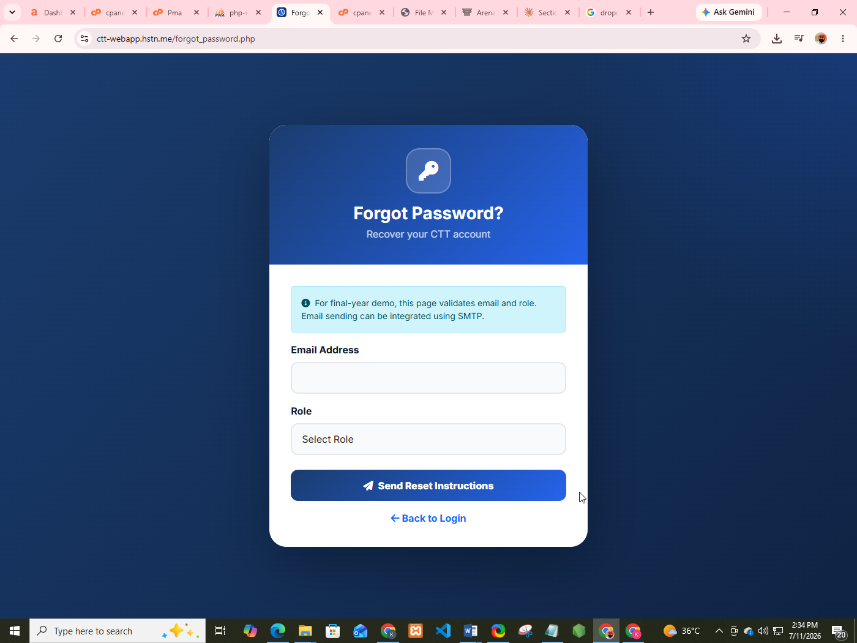
Figure 6.3: Forgot Password Page
3.5 Sign Up / Registration (Teachers & Students Only)
Administrator and Academic In-Charge accounts are created by the institution. Teachers and Students may self-register if the college allows it.
Step 1: On Login page, click Create New Account.
Step 2: Select role: Teacher or Student.
Step 3: Fill the form:
Field | Required? | Example
Full Name | Yes | Muhammad Ali
Email Address | Yes | ali@college.edu.pk
Department | No | Computer Science
Designation (Teacher only) | No | Lecturer
Roll Number (Student only) | Yes | BSCS-F22-001
Semester (Student only) | No | 4th Semester
Username | Yes | ali_teacher
Password | Yes | Min 6 characters
Confirm Password | Yes | Same as password
Terms & Conditions | Yes | Must tick checkbox

Step 4: Click Create My Account.
Step 5: Success screen appears → click Proceed to Login.
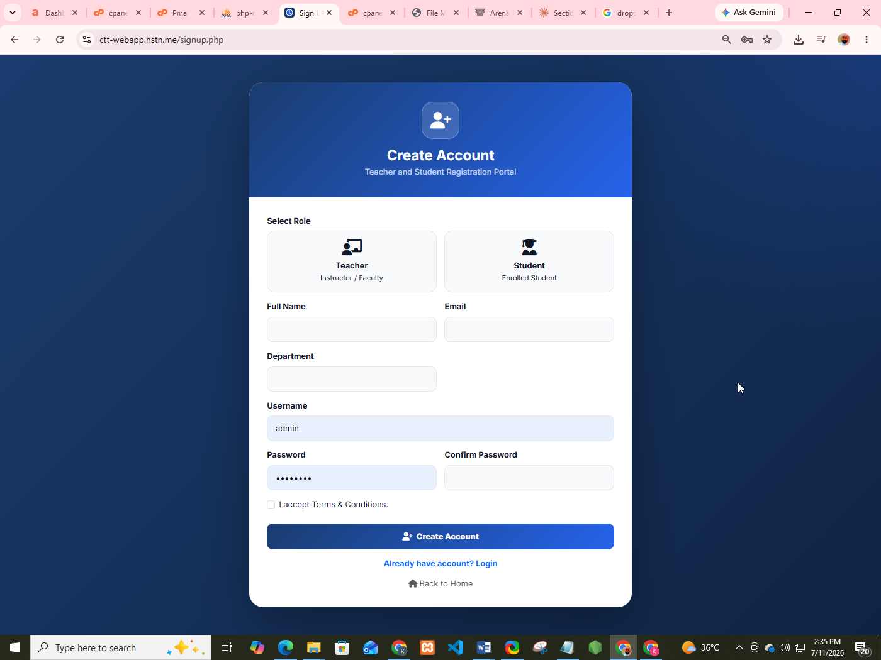

Figure 6.4: Sign Up Page

4. Administrator User Manual
Administrator has full system control.

4.1 Admin Dashboard Overview
After login, you land on the Admin Dashboard.


Figure 6.5: Admin Dashboard — Shows welcome banner, statistics cards, quick action buttons, recent teachers list, recent students list.

Dashboard Sections Explained
1. Welcome Banner
- Shows your name and today's date
- Example: Welcome back, Admin! Today is Monday, March 16, 2026
2. Statistics Cards (System Overview)

Card | Meaning
Academic In-Charge | Total In-Charge accounts
Teachers | Total teacher accounts
Students | Total student accounts
Timetables | Total timetable records
Programs | Total academic programs
Classes | Total classes
Subjects | Total subjects
Rooms | Total rooms

3. Quick Actions
Click any card to jump directly:
- Add In-Charge
- Add Teacher
- Add Student
- Add Program
- Add Class
- Add Subject
- Add Room
- Timetable Builder
4. Recent Activity Tables
- Recent Teachers (latest 5)
- Recent Students (latest 5)
  - Admin Sidebar Menu

Menu Item | Purpose
Dashboard | System overview
Academic In-Charge | Manage In-Charge accounts
Teachers | Manage teacher accounts
Students | Manage student accounts
Programs | Manage academic programs
Classes | Manage classes
Subjects | Manage subjects
Sections | Manage sections
Rooms | Manage rooms
Periods | Manage time periods
Timetable Builder | Create/edit timetable entries
View Timetable | Full grid view + export/print
Reports | Workload and analytics
Logout | Secure logout

4.3 Manage Academic In-Charge Accounts (FR02)
View All In-Charge Accounts
Step 1: Sidebar → Academic In-Charge
Step 2: Table shows: Name, Username, Email, Department, Actions

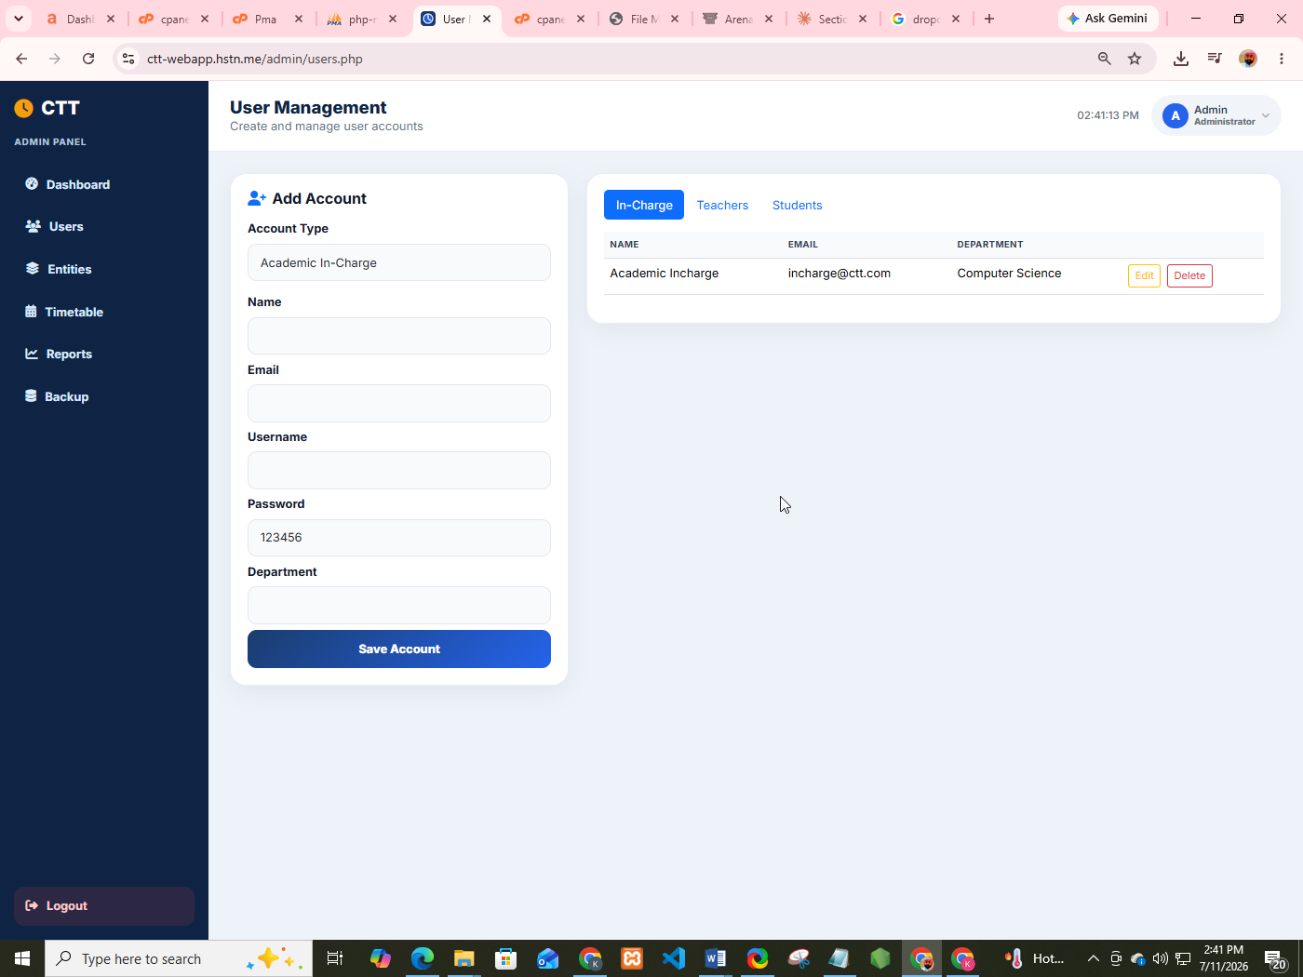
Figure 6.6: Manage In-Charge List

Add New In-Charge
Step 1: Click Add New button.
Step 2: Fill form:
Field | Example
Full Name | Ayesha Khan
Email | ayesha@ctt.edu.pk
Username | ayesha_incharge
Department | Computer Science
Password | 123456 (or leave blank for default)

Step 3: Click Save.
Step 4: New In-Charge appears in the list.

Edit In-Charge
Step 1: Click the Edit (pen) icon next to a record.
Step 2: Update fields.
Step 3: Click Save. (Leave password blank if you do not want to change it.)

Delete In-Charge
Step 1: Click the Delete (trash) icon.
Step 2: Confirm the popup: Delete this record?
Step 3: Record is removed.

4.4 Manage Teachers (FR08 / Admin Level)
Path: Sidebar → Teachers
Same process as In-Charge:
- Add New → Name, Email, Username, Department, Designation, Password
- Edit → update details
- Delete → confirm and remove

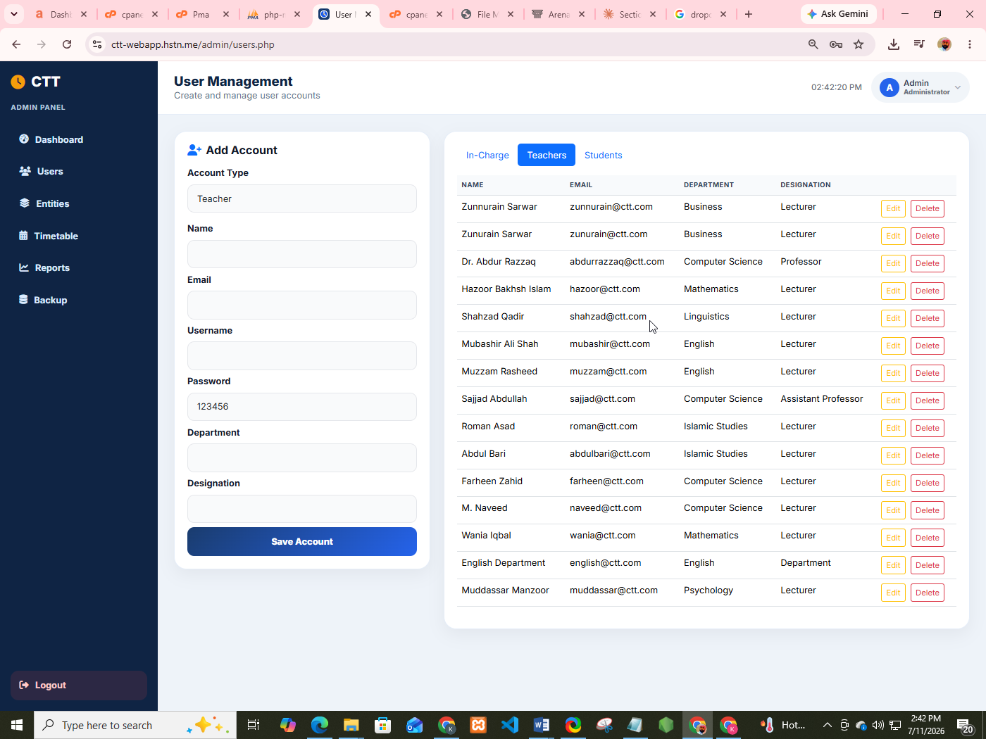
Figure 6.7: Manage Teachers Screen
  - Manage Students
Path: Sidebar → Students
Field | Notes
Full Name | Required
Roll Number | Required + Unique
Email | Required + Unique
Username | Required + Unique
Department | Optional
Semester | Select from dropdown (1st–8th)
Password | Default 123456 if blank

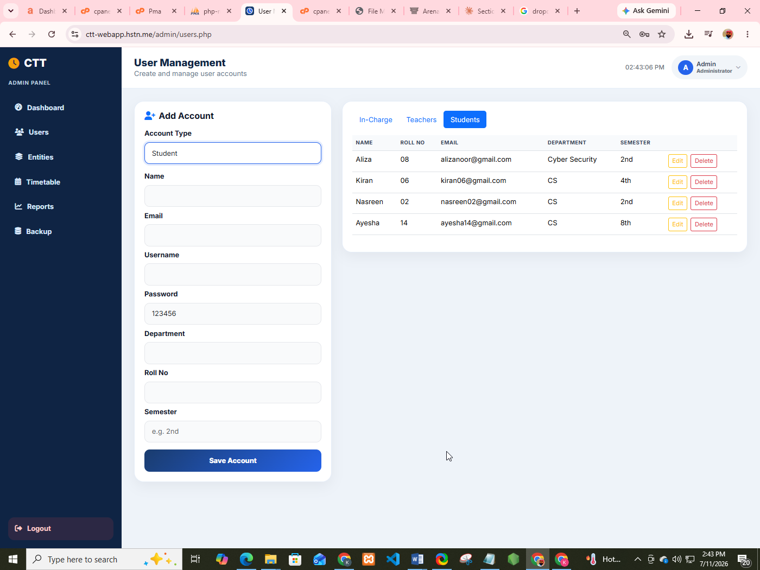
Figure 6.8: Manage Students Screen
4.6 Manage Academic Entities
1. Programs
Path: Sidebar → Programs
Field | Example
Program Name | BSCS
Academic System | Semester / Annual / Quarter

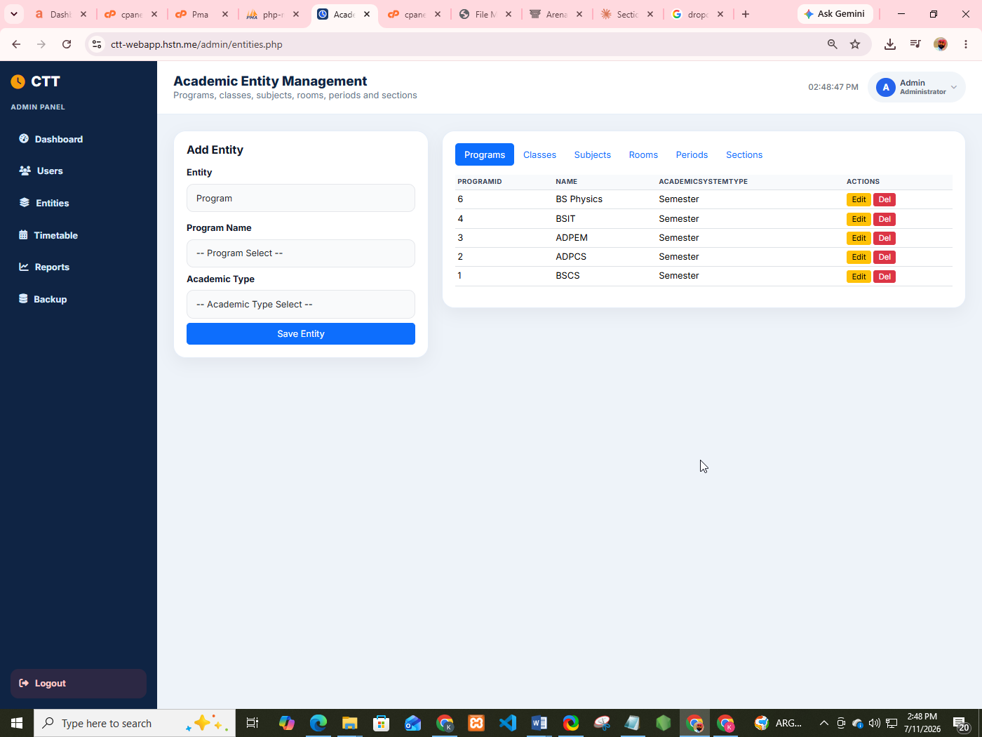
Figure 6.9: Manage Programs Screen
2. Classes
Path: Sidebar → Classes
Field | Example
Class Name | BSCS 2nd Semester
Session | 2025-27
Current Semester | 2nd
Timetable Shift | Morning Shift Timetable
Program | BSCS
Row Color | Green (for grid display)
Important Dates | Mid Term Exam 13.04.26 ...
Display Order | 1
Active | Tick checkbox
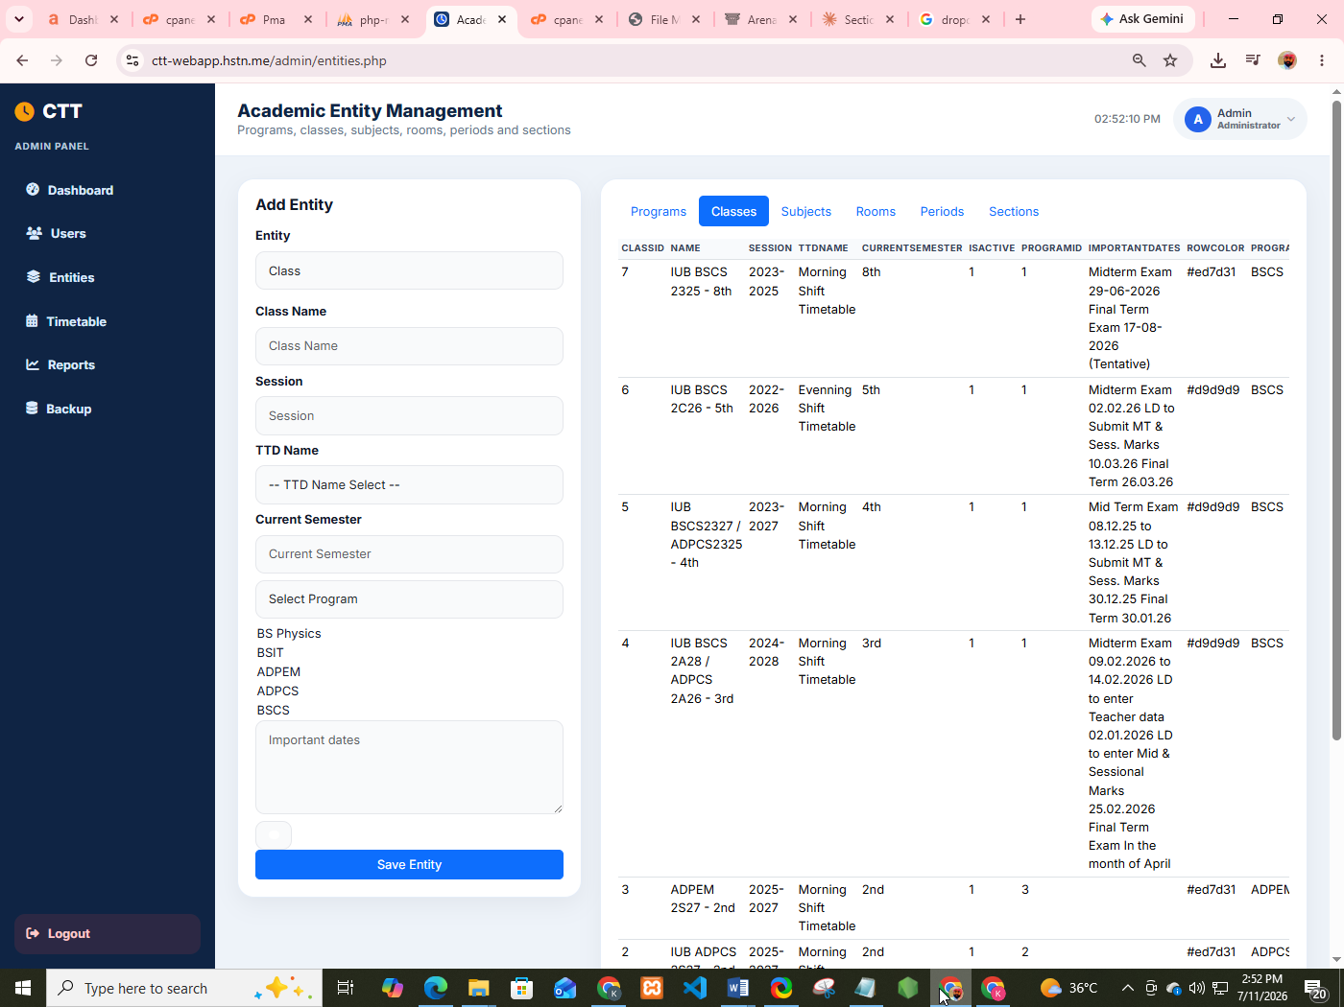

Figure 6.10: Manage Classes Screen
3. Subjects
Path: Sidebar → Subjects
Field | Example
Subject Name | Data Structures
Class | BSCS 2nd Semester
Semester | 2nd Semester
Display Order | 1

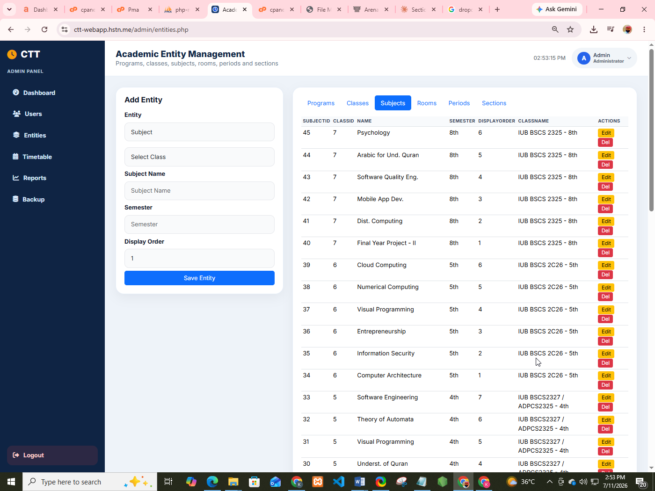
Figure 6.11: Manage Subjects Screen
4. Sections
Path: Sidebar → Sections
Field | Example
Section Name | A / Regular / Morning
Semester | 2nd
Subject | Data Structures
Teacher | Sajjad Abdullah
Active | Yes

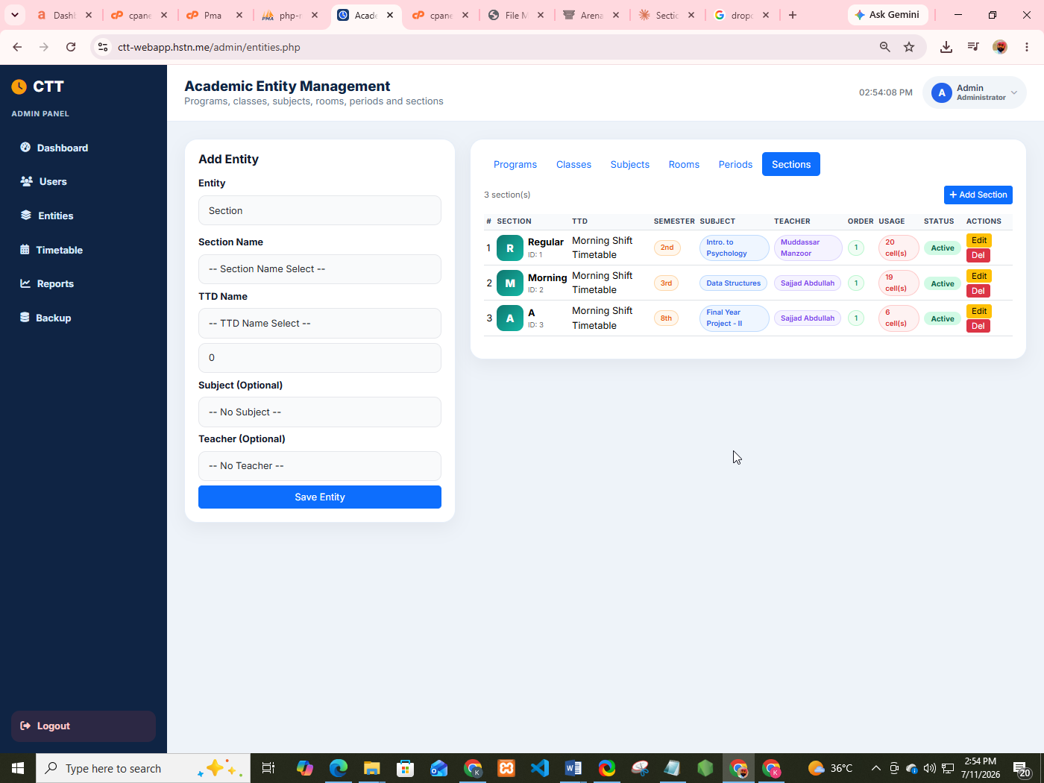
Figure 6.12: Manage Sections Screen
5. Rooms
Path: Sidebar → Rooms
Field | Example
Room Title | Room No. 15 / Comp. Lab 1
Timetable Shift | Morning Shift Timetable

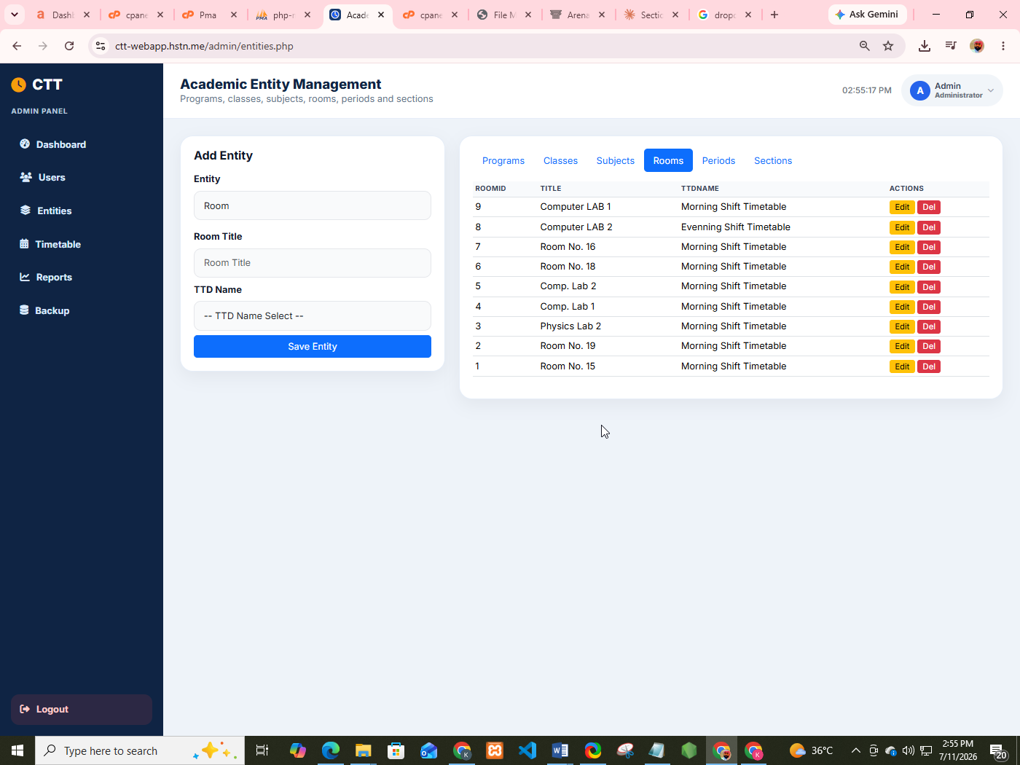

Figure 6.13: Manage Rooms Screen
6. Periods
Path: Sidebar → Periods
Field | Example
Title | Period 1
Number | 1
Start Time | 08:30
End Time | 09:20
Friday Start | 08:30
Friday End | 09:15
Display Order | 1

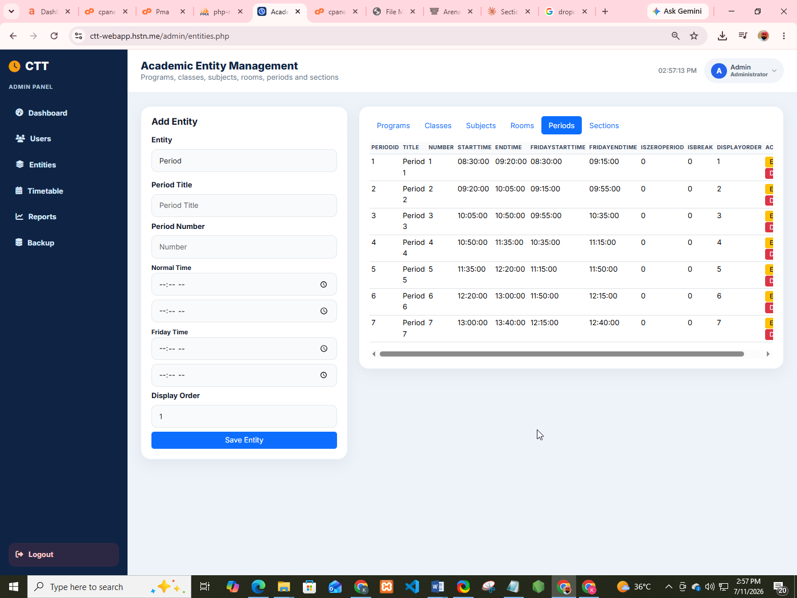
Figure 6.14: Manage Periods Screen
4.7 Timetable Builder (Most Important Admin Feature)
Path: Sidebar → Timetable Builder
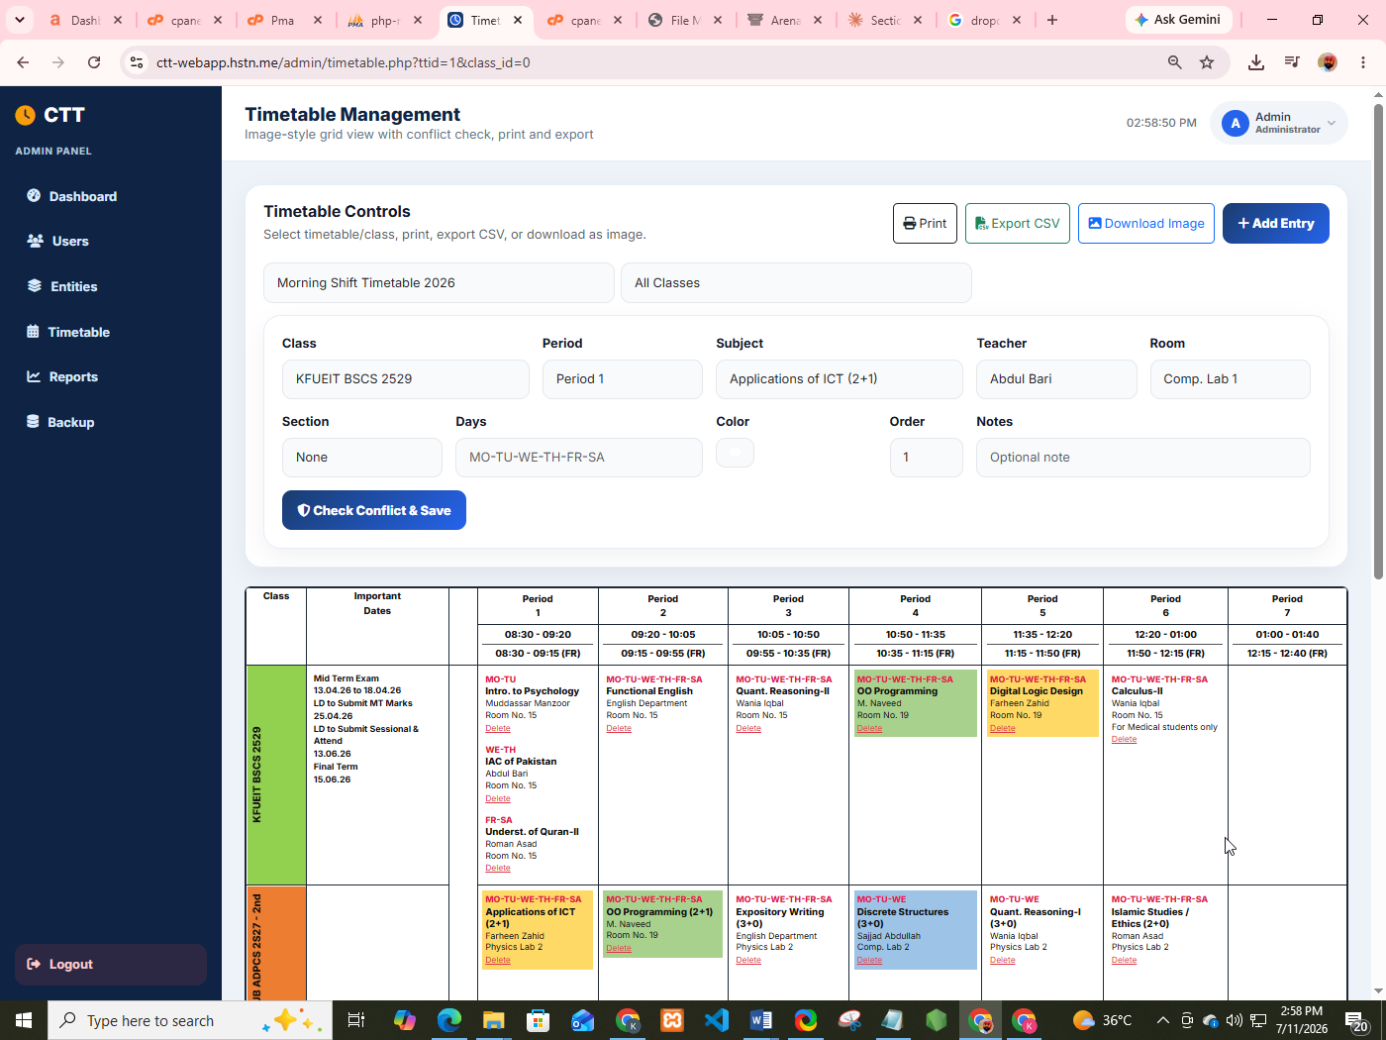

Figure 6.15: Timetable Builder Page — Top form to add entry + list of all entries + live grid preview at bottom.

How to Add a Timetable Entry
Step 1: Open Timetable Builder.
Step 2: In the "Add Timetable Entry" form, select:
Field | Example
Class * | BSCS 2nd Semester
Period * | P1 (08:30-09:20)
Subject | Intro. to Psychology
Teacher | Mudassar Manzoor
Room | Room No. 15
Section | Regular
Days | MO-TU

Step 3: Click Add Entry.
What Happens Internally?
- System checks if the teacher is free in that period on those days.
- If no conflict → entry is saved and grid updates.
- If conflict → red error appears: "Conflict! This teacher is already assigned to another class in this period on overlapping days."

View All Entries Table
Below the form you will see a table of all saved entries with:
- Class, Period, Subject, Teacher, Room, Days
- Conflict badge (if any)
- Delete button for each entry

Live Preview Grid
At the bottom, the full timetable grid updates automatically after every add/delete.
Delete an Entry
Step 1: In the entries table, click the trash icon.
Step 2: Entry is removed and grid refreshes.
4.8 View Full Timetable (Export & Print)
Path: Sidebar → View Timetable

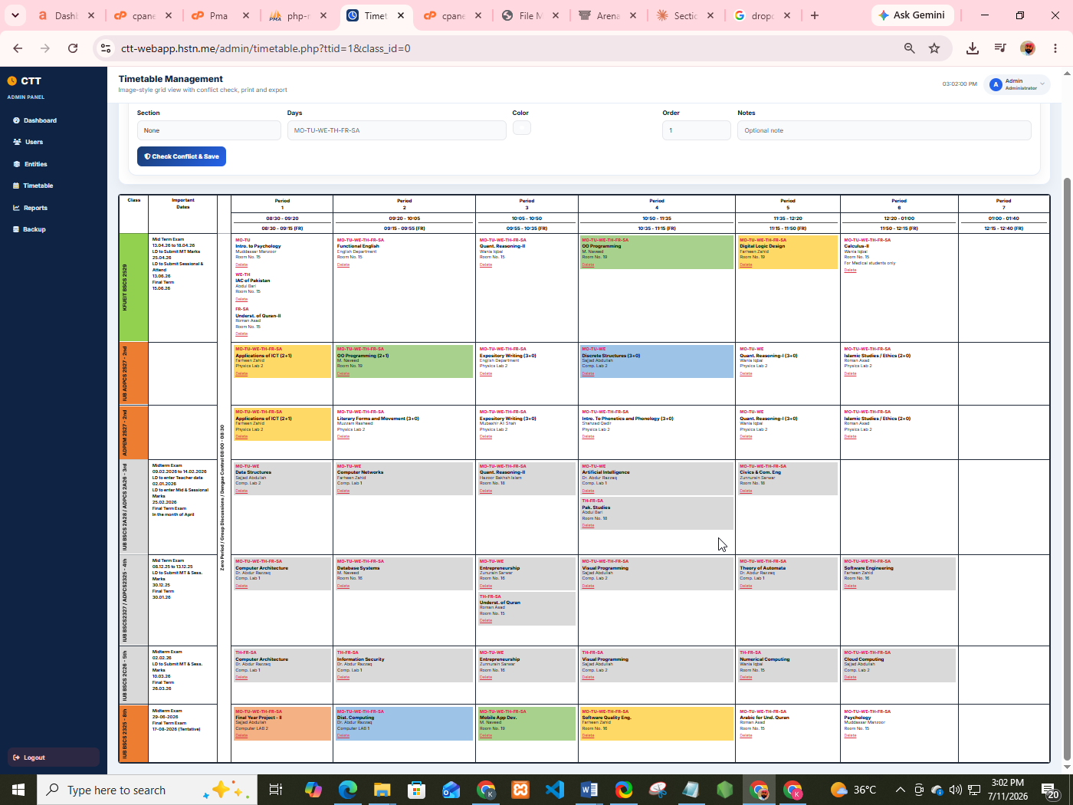
Figure 6.16: Full Timetable Grid View — Class rows × Period columns, Important Dates column, colored class labels, subject/teacher/room in cells.
Toolbar Buttons
Button | Action
Print | Opens browser print dialog (landscape recommended)
Export CSV | Downloads timetable.csv file

Conflict Banner
- Green badge: No conflicts
- Red badge: X conflict(s) detected + list of conflicting teachers
How to Print Professionally
Step 1: Click Print.
Step 2: In print settings:
- Layout: Landscape
- Margins: Minimum
- Background graphics: On (optional for colors)
Step 3: Click Print or Save as PDF.
4.9 Reports Module
Path: Sidebar → Reports

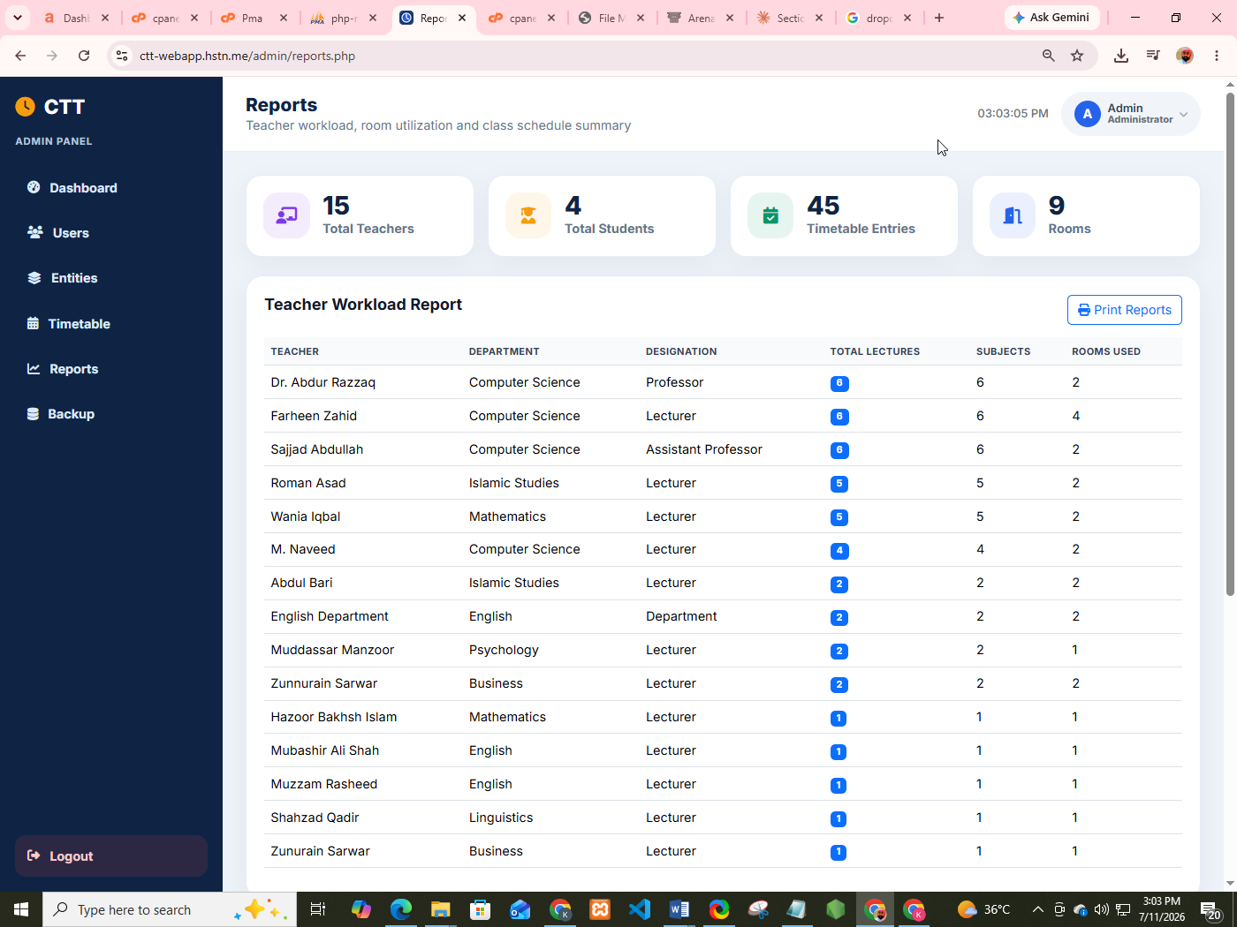
Figure 6.17: Reports Page

Available Reports
1. Teacher Workload Report
Columns:
- Teacher Name
- Department
- Designation
- Number of Classes Taught
- Weekly Periods Assigned
2. Class Load Report
Columns:
- Class Name
- Distinct Subjects
- Scheduled Periods
3. Conflict Summary
- Total conflicts detected
- Detailed conflict messages
Print Report: Click Print Report button → browser print dialog.
4.10 Database Backup / Restore (Conceptual)
Path: (If implemented) Sidebar → Database Backup

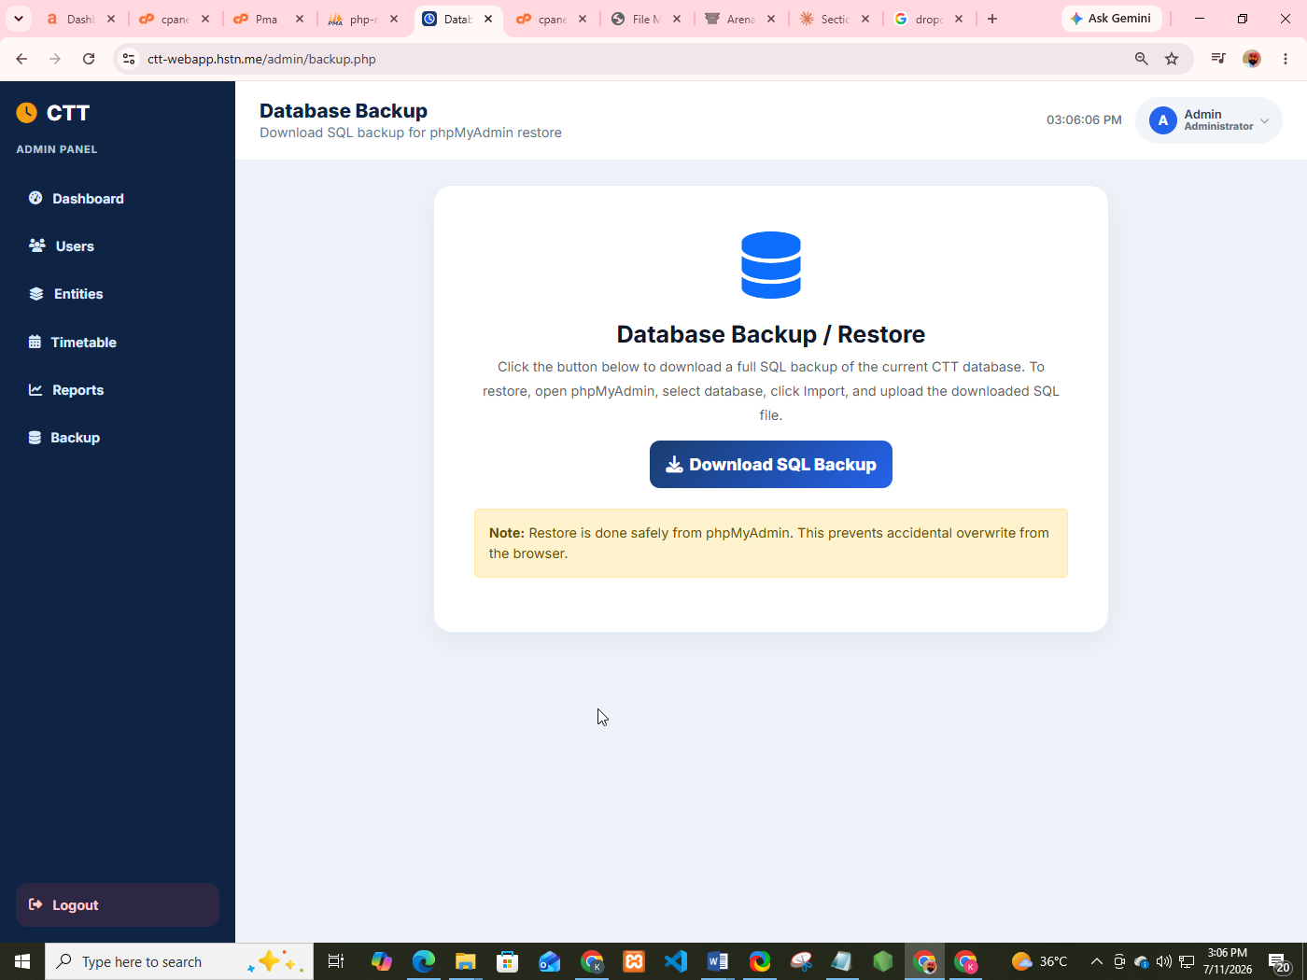

Figure 6.18: Database Backup / Restore Page Screen
Backup Steps:
- Click Download Backup.
- SQL file downloads to your computer.
- Store it safely.
Restore Steps:
- Open phpMyAdmin.
- Select ctt_db.
- Import the SQL backup file.

5. Academic In-Charge User Manual
Academic In-Charge manages day-to-day academic operations.
5.1 In-Charge Dashboard

Figure 6.19: In-Charge Dashboard — Welcome banner (green theme), stats for Teachers/Students/Subjects/Timetables, quick actions, recent students table.

Sidebar Menu (In-Charge)
Menu Item | Purpose
Dashboard | Overview
Teachers | Manage teachers
Students | Manage students
Subjects | Manage subjects
Sections | Manage sections
Timetable Builder | Build schedule
View Timetable | Full grid + export/print
Reports | Workload reports
Logout | Exit

5.2 What In-Charge Can Do
Feature | Allowed?
Manage Teachers | Yes
Manage Students | Yes
Manage Subjects / Sections | Yes
Build Timetable | Yes
View / Export / Print Timetable | Yes
View Reports | Yes
Manage In-Charge accounts | No (Admin only)
Database Backup | No (Admin only)

5.3 Typical Daily Workflow for In-Charge
Step 1: Login → Dashboard
Step 2: Add new teachers/students if needed
Step 3: Ensure subjects and rooms are complete
Step 4: Open Timetable Builder
Step 5: Add entries carefully (watch for conflict messages)
Step 6: Open View Timetable to verify grid
Step 7: Export CSV / Print for notice board
Step 8: Check Reports for teacher workload balance
Step 9: Logout

6. Teacher User Manual
Teachers have a simple, read-focused portal.
6.1 Teacher Dashboard

Figure 6.20: Teacher Dashboard — Purple welcome banner, stats (Weekly Classes, Classes Taught, Rooms), My Teaching Schedule table.

What Teachers See
Section | Description
Welcome Banner | Name + Designation + Department
Weekly Classes | Total assigned periods
Classes Taught | Number of distinct classes
Rooms | Number of rooms used
My Teaching Schedule | Detailed table of all assignments

My Teaching Schedule Table Columns
Column | Meaning
Class | Which class you teach
Subject | Subject name
Days | e.g., MO-TU-WE
Period | e.g., P2 (09:20-10:05)
Room | Room number

6.2 View Full Timetable
Path: Sidebar → Full Timetable
- Full college grid opens
- Your classes are highlighted (other entries appear dimmed)
- You can still Print / Export CSV
6.3 What Teachers Cannot Do
- Cannot add/edit/delete timetable entries
- Cannot manage users
- Cannot change other teachers' schedules
7. Student User Manual
Students have the simplest interface.

7.1 Student Dashboard

Figure 6.21: Student Dashboard — Orange/gold welcome banner, Roll No / Department / Semester cards, class timetable grid.

What Students See
Card | Content
Roll Number | e.g., 14
Department | e.g., CS
Semester | e.g., 8th Semester
Class Timetable | Grid filtered/highlighted for their semester

7.2 How Student Timetable Matching Works
Step 1: System reads student's Semester field.
Step 2: Matches it with class Current Semester.
Step 3: Highlights that class row in the grid.
Step 4: Other classes appear dimmed.
7.3 View Full Timetable
Path: Sidebar → Full Timetable. Same as teacher — full grid, print, export.
7.4 What Students Cannot Do
- Cannot edit anything
- Cannot see other students' personal data
- Cannot access admin/in-charge modules
8. Common Features (All Roles)
8.1 Responsive Design (Mobile / Tablet)
- On mobile, sidebar collapses into a hamburger menu (☰) top-left.
- Tap ☰ to open/close navigation.
- Timetable grid scrolls horizontally on small screens.
8.2 Print Feature
Works on: Full Timetable page and Reports page.
Print tips:
- Always choose Landscape orientation
- Enable background graphics if you want colors
- Use "Save as PDF" to create soft copies for WhatsApp/email
8.3 CSV Export
Step 1: Open Full Timetable.
Step 2: Click Export CSV.
Step 3: File timetable.csv downloads.
Step 4: Open in Excel / Google Sheets.

8.4 Session Security
- Session expires after inactivity (or browser close, depending on settings).
- Always logout on shared computers.
- Passwords are never shown in plain text.
9. Troubleshooting Guide
Problem | Possible Cause | Solution
Cannot login | Wrong username/password | Reset password / contact admin
Page not loading | Server down / wrong URL | Check XAMPP Apache/MySQL are running
Conflict error while saving | Teacher already booked | Choose different teacher, period, or days
Timetable grid empty | No entries added yet | Use Timetable Builder to add entries
Student sees wrong class | Semester not set correctly | Admin/In-Charge updates student's semester
Print cuts off columns | Portrait mode used | Switch to Landscape
CSV not downloading | Browser blocked download | Allow downloads for the site
Sidebar not visible on phone | Menu collapsed | Tap hamburger (☰) icon
"Email already exists" | Duplicate registration | Use another email or login instead
Session expired suddenly | Long inactivity | Login again

10. Frequently Asked Questions (FAQs)
Q1: Who can create Administrator accounts?
A: Only an existing Administrator (or database seed script during installation).

Q2: Can a Teacher edit the timetable?
A: No. Only Administrator and Academic In-Charge can edit.
Q3: What does "MO-TU-WE-TH-FR-SA" mean?
A: Days of the week: Monday, Tuesday, Wednesday, Thursday, Friday, Saturday.
Q4: Can one cell have multiple subjects?
A: Yes. Example: Period 1 of BSCS 2nd may have MO-TU Psychology and WE-TH IAC of Pakistan.
Q5: How does conflict detection work?
A: System checks if the same teacher is assigned to a different class in the same period on any overlapping day. If yes, save is blocked.
Q6: Can I use CTT offline?
A: Only if hosted on a local college LAN. Fully offline (no server) is not supported.
Q7: How do I change my password?
A: Contact Admin/In-Charge to reset, or use profile update if available for your role.
Q8: Is my data safe?
A: Passwords are hashed. Role-based access prevents unauthorized module entry. Use HTTPS on live servers for full safety.
Q9: Can multiple In-Charge users work at the same time?
A: Yes, but they should coordinate to avoid editing the same timetable simultaneously.
Q10: What file formats can I export?
A: CSV (Excel) and Print-to-PDF (browser print).
11. Glossary of Terms
Term | Meaning
CTT | College Time Tracker
RBAC | Role-Based Access Control
Period | A fixed time slot (e.g., 08:30–09:20)
Class | Academic group (e.g., BSCS 2nd Semester)
Section | Sub-group of a class (A, B, Regular)
Conflict | Overlapping assignment of teacher/room
Dashboard | Home screen after login for each role
Grid | Visual matrix of Class rows × Period columns
CSV | Comma-Separated Values (Excel-compatible file)
Session | Secure login state stored in browser cookie
CRUD | Create, Read, Update, Delete operations
In-Charge | Academic In-Charge (timetable coordinator)

12. Quick Reference Card (One-Page Summary)
Login
Home → Login → Username + Password → Sign In
Admin Core Tasks
Dashboard → Users/Entities → Timetable Builder → View Timetable → Reports
In-Charge Core Tasks
Dashboard → Teachers/Students → Timetable Builder → Export/Print
Teacher Core Tasks
Dashboard → My Teaching Schedule → Full Timetable (highlighted)
Student Core Tasks
Dashboard → My Class Timetable → Full Timetable
Emergency Contacts
- Technical Support: admin@ctt.edu.pk
- Academic Coordination: incharge@ctt.edu.pk

Chapter 7:

Conclusion and

Future Enhancement

7.1 Conclusion
The College Time Tracker system successfully achieves its primary objective of automating the academic timetable creation process while preventing scheduling conflicts through role-based access and an automated conflict-detection engine. All 17 functional requirements identified during the requirements analysis phase were implemented and verified through structured black-box testing, achieving a high pass rate. The system evaluation confirms that CTT significantly reduces the manual effort involved in timetable preparation and provides teachers and students with immediate, accurate access to their personal schedules.

7.2 Limitations
- The system does not currently support multi-campus deployment.
- Notifications (SMS/Email) for timetable changes are not implemented.
- The system assumes a single academic session is active at a time.

7.3 Future Enhancements
- Integration of an SMS/Email notification module for schedule changes.
- Development of a native mobile application for Android and iOS.
- Cloud-based deployment with automated database backups.
- AI-based automatic timetable generation using constraint-satisfaction algorithms.
- Integration of biometric attendance with the timetable module.

Chapter 8:

References

APA Format
1. Sommerville, I. (2016). Software Engineering (10th ed.). Pearson.
2. Elmasri, R., & Navathe, S. B. (2015). Fundamentals of Database Systems (7th ed.). Pearson.
3. Pressman, R. S., & Maxim, B. R. (2019). Software Engineering: A Practitioner's Approach (9th ed.). McGraw-Hill.
4. W3Schools. (2024). PHP Tutorial. https://www.w3schools.com/php/
5. MySQL Documentation. (2024). MySQL 8.0 Reference Manual. https://dev.mysql.com/doc/
6. Bootstrap Team. (2024). Bootstrap 5 Documentation. https://getbootstrap.com/docs/5.3/
7. PHP Documentation Group. (2024). PHP Manual. https://www.php.net/manual/en/
8. IEEE. (1998). IEEE Recommended Practice for Software Requirements Specifications (IEEE Std 830-1998). IEEE.
9. OWASP Foundation. (2023). OWASP Top Ten Web Application Security Risks. https://owasp.org/www-project-top-ten/
10. Fowler, M. (2018). UML Distilled: A Brief Guide to the Standard Object Modeling Language (3rd ed.). Addison-Wesley.

